

**Word Embeddings**

**Coursework 2024/2025**Steve Galea (0015902H)

Study-unit: **Topics in Applied Data Science**

Code: **CIS5231**

Lecturer: Professor John Abela

**FACULTY OF INFORMATION AND COMMUNICATION TECHNOLOGY**

Declaration Plagiarism is defined as “the unacknowledged use, as one's own, of work of another person, whether or not such work has been published, and as may be further elaborated in Faculty or University guidelines" (University Assessment Regulations, 2009, Regulation 39 (b)(i), University of Malta).

I, the undersigned, declare that the assignment submitted is my work, except where acknowledged and referenced.

I understand that the penalties for committing a breach of the regulations include loss of marks; cancellation of examination results; enforced suspension of studies; or expulsion from the degree programme.

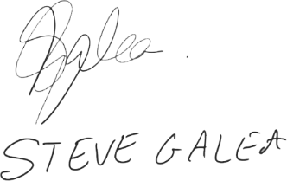Work submitted without this signed declaration will not be corrected, and will be given zero marks.

STEVE GALEA __________

Student Name Signature

Word Embeddings Coursework 2024/2025

CIS5231

Course Code Title of work submitted

18/07/2025

Date

# Table of Contents

Contents

Table of Contents 3

Table of Figures 4

Introduction 5

Literature Review Of Word Embedding Techniques 6

Design Decisions: 9

1. Acquisition and Pre-Processing (1_data_pre_processing.py) 9

2. Models in models/cbow.py and models/skipgram.py 11

3. Training Process (2_and_3_pytorch_model_training_and_optimisations.py) 13

3.1 Training Loop Implementation 13

3.2 Hyper-Parameter Tuning 14

3.3 Performance Monitoring 15

3.4 Adaptation 15

4. Visualisation Techniques Used (4_tSNE_visualisation_and_analysis.py) 15

Discussion of results 18

Challenges Encountered 29

Possible Enhancements/Further work 29

Convergence Plots & tSNE embeddings 30

Source Code Appendix 59

References 69

ChatGPT usage 70

# Table of Figures

Figure 1.1: The above figure was replicated from Mikolov et al. [4], showing the two distinct architectures. 7

Figure 1.1: Initial raw data set, with business and sports news articles 9

Figure 4.1: Example plot showing similar/opposite words being plotted in a space. 17

Figure 4.2: The figure shows the full list of experiments conducted available on Github SteveGalea/CIS5231 17

Figure 4.1: Skipgram 0.01 learning rate (left) vs Skipgram 0.001 learning rate 19

Figure 4.2: CBOW 0.01 learning rate (left) vs CBOW 0.001 learning rate (right) 19

Figure 4.3: CBOW 32 batch size(left) vs CBOW 256 batch size (right) 20

Figure 4.4: CBOW 16 batch size (left) vs CBOW 256 batch size (right) 20

Figure 4.5: SkipGram 64 batch size (left) vs SkipGram 256 batch size (right) 21

Figure 4.6: SkipGram 64 batch size (left) vs SkipGram 256 batch size (right) 21

Figure 4.7: Skip-gram (batch 256, learning rate 0.01) window size 2 (left) vs Skip-gram (batch 256, learning rate 0.01) window size 5 (right) 22

Figure 4.8: Skip-gram (batch 32, learning rate 0.0001) 10 window size (left) vs skip-gram (batch 256, learning rate 0.05) window size 10 (right) 22

Figure 4.9: CBOW (batch 256, learning rate 0.01) window 2 (left) vs window 5 (right) 23

Figure 4.10: The business category, for **Skip-gram (batch 256, learning rate 0.01), window size** **5**. 24

Figure 4.11: The colour category for **Skip-gram (batch 256, learning rate 0.01), window size** **5**. 24

Figure 4.12: The country category for **Skip-gram (batch 256, learning rate 0.01), window size** **5**. 25

Figure 4.13: The gender category for **Skip-gram (batch 256, learning rate 0.01), window size** **5**. 26

Figure 4.14: The position category for Skip-gram (batch 256, learning rate 0.01), window size 5. 26

Figure 4.15: The royalty category for Skip-gram (batch 256, learning rate 0.01), window size 5. 27

Figure 4.16: The sport category for Skip-gram (batch 256, learning rate 0.01), window size 5. 28

# Introduction

**The Code for this assignment can be found on GitHub with all the binaries and trained models:** [**SteveGalea/CIS5231**](https://github.com/SteveGalea/CIS5231)

Applications of word embedding techniques are wide-ranging — from text classification, text generation (such as summarisation), and question answering, to speech recognition and machine translation. To achieve the above, word embedding techniques map words, along with their surrounding context at times, into continuous vector spaces [1].

Word Embeddings are a type of Vector Space Model used in Natural Language Processing (NLP) that are learnt from large data corpora in an unsupervised manner. These models identify patterns from language data sources and represent them as dense and continuous vectors. Unlike one-hot encoded data, which is a sparse representation, using such vectors for representations offers various benefits [1]. Within the domain of NLP, word embeddings can be learned using prediction-based models that rely on local context or through count-based models that leverage global word occurrences [11].

Dense vectors are computationally less expensive and do not require human curation or extensive manual feature engineering to represent a word numerically. The word vector is determined effectively through its context, and such vector embeddings enable models to handle noise or missing data better, make generalisations and inferences from unseen data. This is because word embeddings capture the semantic similarity and cluster words with similar meaning together in the embedding space. This is very unlike rule-based symbolic methods, relying on direct human labelling and offering limited scalability and vocabulary. In dense vector word embeddings[1-3]. Dense vectors produced by earlier models like Word2Vec are static representations, meaning that the vector does not account for revision of the vector representation, even if the context is different. This limitation of polysemy and homonymy is addressed by later models like BERT and ELMo [3]. These vector embeddings have become foundational components of modern neural architectures and deep sequence models [1,3, 8-11]. Notably, Vaswani et al. [10] incorporated them into the multi-layered Transformer architecture, which ultimately paved the way for models like ChatGPT.

# Literature Review Of Word Embedding Techniques

Mikolov et al. [4] and Pennington et al. [5] produced Word2Vec and GloVe models, respectively, to come up with highly accurate semantic word encodings. Other models, such as FastText, created by Joulin et al. [6] and Bojanowski et al. [7], BERT by Devlin et al. [8], or ELMo by Peters et al. [9], aimed to address limitations in the vectors encountered by the previous two models.

Mikolov et al [4] created the Continuous Bag Of Words (CBOW) and Skip-gram architectures to compress words from very large datasets into a dense set of vectors via a log-linear classifier. CBOW and Skip-gram both make use of feed-forward functions, aiming to learn word representations. CBOW employs a feed-forward network function which accepts as input a context of many words, with a missing middle target word. CBOW hence tries to predict the central target word from the surrounding words. The order of the words does not matter. Skip-gram is the opposite, where with a target word as an input, it tries to predict the surrounding context. It is more complex computationally than CBOW when the context window range is increased to consider distant word vectors; however, the quality of the overall word vectors is increased. These two architectures were tested with the Google News 6B token corpus, and the vocabulary tested was limited to the most frequent 1 million, and later 30 thousand words, due to time constraints. The experiments carried out involved experimenting with 1 or 3 epochs; varying (e.g. 300 or 600) embedding dimensionality; 783M or 1.6B words, and of course CBOW or Skip-gram. The model was trained with mini-batches, backpropagation and Adagrad stochastic gradient descent (learning rates 0.025 to 0) on a single CPU. Large-scale tests were carried out as well with multiple CPU instances using the full 6B dataset, and 1000-sized embedding dimensions for both architectures. For word similarity and analogy evaluation tasks, various semantic and syntactic questions were carried out to evaluate the accuracy, with the authors coming up with various relationships (e.g. France – Paris, USA - pizza, cold - colder). n. With larger datasets and larger embedding dimensions, the authors indicate that the performance increases, and high-quality embeddings can be achieved with a simple architecture.

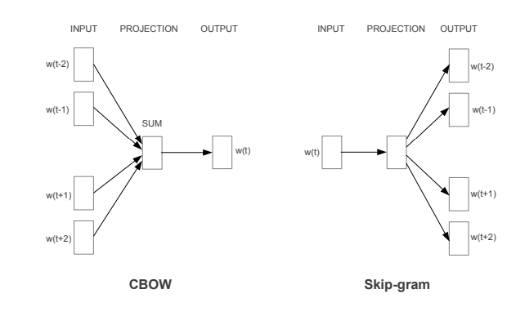

Figure .: The above figure was replicated from Mikolov et al. [4], showing the two distinct architectures.

Pennington et al. [5] combine the benefits of the global matrix factorisation methods (e.g. latent semantic analysis (LSA)) and the local context window models achieved by Mikolov et al [4] (Skip-gram). GloVe counts the word occurrences in the provided corpus as a word-context co-occurrence matrix, extracts probabilities and factorises them. This effectively captures the global probabilities and relationships within the corpus, unlike Word2Vec, which focuses on a local window context. The same Semantic and Syntactical tests as Mikolov et al. [4] were carried out over different models and hyperparameters. The datasets used were Wikipedia dumps from 2010 and 2014 and Gigaword5, to obtain 6 billion tokens. The top 400,000 most frequent words were used, 300+ vector embeddings (trained with 50 epochs for <300, but 100 epochs for >300), and Adagrad with an initial learning rate of 0.05 was used. An investigation into the left and right sentence contexts was made. The GloVe model outperformed the other baselines, providing superior and faster word vectors and robustly supporting larger datasets. Word similarity, word analogy, and named entity recognition are the NLP tasks for which the GloVe model appears to outperform.

Word2Vec and GloVe, however, both suffer from out-of-vocabulary words as a top X filter is done to limit the vocabulary [3-5]. With this in mind, authors [6-7] created FastText, an extension of the skip-gram model, and in it, it represents each word as an n-gram of characters. The authors made use of Czech, French, Spanish, German, English and Russian Wikipedia dumps for training. The model used was an RNN with 650 LSTM units and trained by Adagrad. It was found that morphologically richer languages like German tend to separate compound nouns into morphemes. Besides that, the FastText model can generate word vectors for out-of-vocabulary words by averaging the n-grams [6-7]. Unfortunately, the n-grams model may not scale, and it can grow rapidly in size, possibly posing a notable limitation.

The limitation of static embedded vectors is a pertinent issue across the simpler models created by [4-7]. BERT by Devlin et al. [8] is a multi-stacked transformer-based bidirectional encoder-decoder architecture that directly generates context-dependent embeddings in the feedforward loop. Two token embeddings are created within BERT to create a dynamic vector representation for the same word, but different contexts through attention mechanisms; the first is WordPiece tokenisation to represent the syntax and semantics, and the second is tokenisation for the position. These two embedded encodings properly handle the limitation of polysemy and homonymy, and the use of bi-directional context, unlike the word embeddings of [4-7] can consider the entire context (instead of a window in Word2Vec Skipgram[4] and FastText [6-7]) from both directions. ELMo by Peters et al. [9] similarly makes use of a bidirectional LSTM architecture to generate dynamic context-dependent embeddings.

# Design Decisions:

## Acquisition and Pre-Processing (1_data_pre_processing.py)

The News Articles[1] dataset was acquired from Kaggle. It contains 2,692 scraped news articles and headlines related to business and sports from 2015 to 2017. For this assignment, since computations will be carried out on a CPU and a domain-specific dataset is needed, the **sports** articles (1408 records) will be focused on.

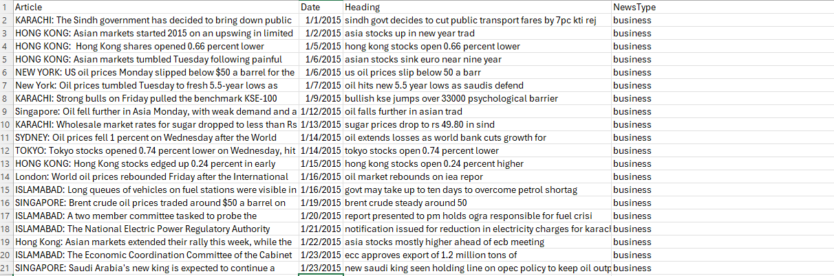

Figure .: Initial raw data set, with business and sports news articles

Pre-Processing Steps:

1. Text Normalisation: Convert all text to lowercase to maintain consistency.

2. Punctuation Removal: Remove punctuation using regular expressions to clean the text, as per the following code snippet.

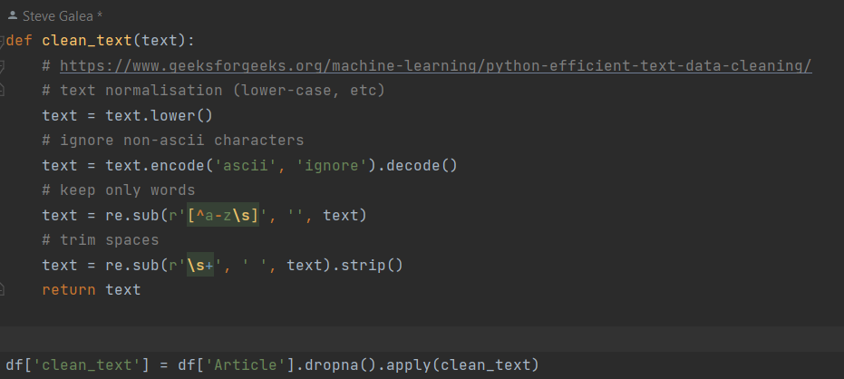

3. Tokenisation: Split text into individual tokens (words) & Stop-Word Removal: Filter out common stop words to reduce noise and focus on semantically rich words..

5. Vocabulary Limiting/Filtering: Construct a vocabulary of the top 10,000 most frequent words, replacing infrequent words with an <UNK> token. Lemmatisation was carried out using **spacy**. Indexing was also carried out, where I converted tokens into numerical indices based on the constructed vocabulary

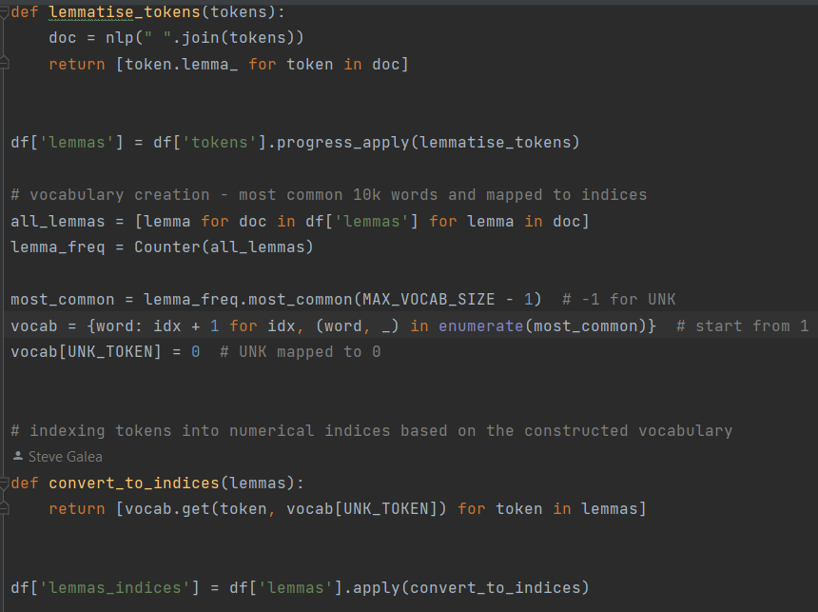

7. Dumping Data created -> the data created was dumped into the Data folder.

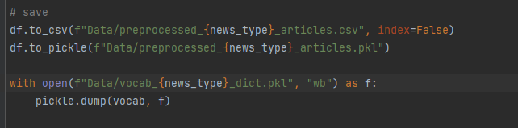

Sample script run:

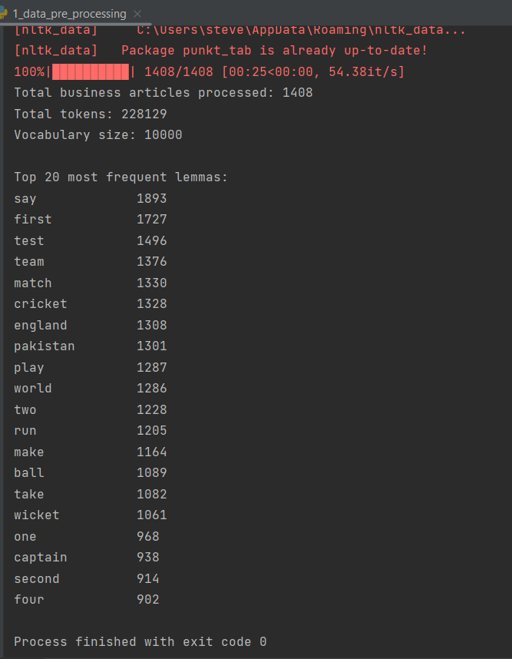

## Models in models/cbow.py and models/skipgram.py

* The models created follow the ChatGPT boilerplate code(prompt in the ChatGPT log attached). This 2 source code links were then used to create the CBOW and Skipgram Code and training loop:
  1. Prompt in the appendix
  2. [pytorch-continuous-bag-of-words/cbow.py at master · FraLotito/pytorch-continuous-bag-of-words · GitHub](https://github.com/FraLotito/pytorch-continuous-bag-of-words/blob/master/cbow.py)
  3. [Skip-Gram Word2Vec Algorithm Explained | by Ido Leshem | Medium](https://leshem-ido.medium.com/skip-gram-word2vec-algorithm-explained-85cd67a45ffa)
* One-hot encoding & Binary vector representation were not used, as dense vector representations are preferred. Instead, training was performed using mini-batches and computing the CrossEntropyLoss & optimisers upon was preferred and put in **2_and_3_pytorch_model_training_and_optimisations.py** handle the training and stochastic descent with Adam.
* Softmax was implemented in both CBOW and Skipgram models to get log-probabilities.

CBOW Model documentation:

* 1. Predicts a target central word, from the context words
  2. Prediction-based model with a simple feed-forward network

CBOW Model attributes:

|  |  |
| --- | --- |
| Attribute | Why needed |
| self.embeddings | Converts word indices to dense vectors. For this assignment, we are using a 256 inner vector dimension |
| embeds.mean | Takes all context words, gets an average, forwards to self.linear |
| self.linear | Layer to receive and forward an average embedding vector from all contexts to be encoded, forwards to log_softmax |
| Log_softmax | Log-probabilities to predict the target word |

|  |  |
| --- | --- |
| Function | Why needed |
| Forward | Receives word indices and outputs target central word log-probabilities, for updating in the training loop in **2_and_3_pytorch_model_training_and_optimisations.py** |

Skipgram Model documentation:

1. Predicts the context, from an initial central word.
2. Also a prediction-based model.

|  |  |
| --- | --- |
| Attribute | Why needed |
| self.embeddings | Converts word indices to dense vectors. For this assignment, we are using a 256 inner vector dimension |
| self.linear | Layer to receive a center word embedding, forwards to log_softmax |
| Log_softmax | Log-probabilities to predict the context words |

|  |  |
| --- | --- |
| Function | Why needed |
| Forward | Receives word index and outputs context log-probabilities, for updating in the training loop in **2_and_3_pytorch_model_training_and_optimisations.py** |

CBOW & Skipgram Dataset:

1. Prepares samples for CBOW/Skipgram model
   1. On get item, CBOW dataset gets a set of contexts and a single target vector from the vocabulary.
   2. On get item, Skipgram dataset gets a single index and a set of context vectors to be predicted from the vocabulary.
   3. As a failsafe, UNK_TOKEN vector is provided in case the index passed is an unseen word

Utility dataset functions:

1. **generate_cbow_data:** iterates over a token list and generates (context, target) vector pairs
2. **generate_skipgram_data:** iterates over a token list, and prepares the center tokens according to the window used.

The embeddings for both models are updated in the training loop after calculating the CrossEntropyLoss by **loss.backward()**. The Adam optimizer applies the gradients at this point using **optimizer.step(),** as in the snippet in **3.1 Training Loop Implementation.**

## Training Process (2_and_3_pytorch_model_training_and_optimisations.py)

## Training Loop Implementation

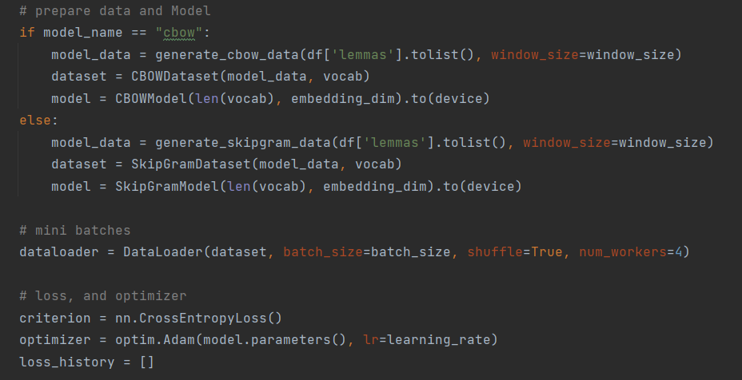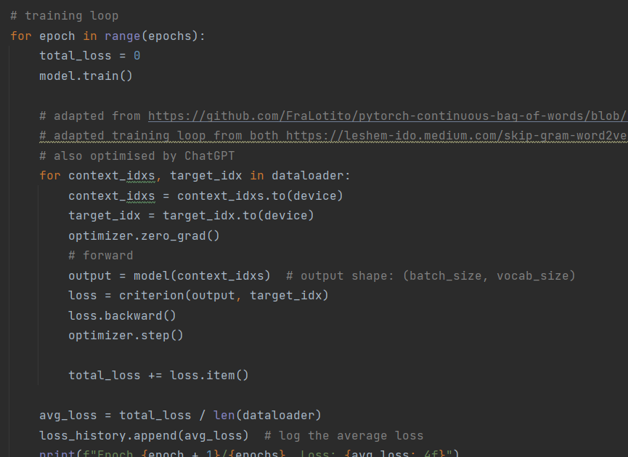

As seen above, the necessary data loader is called, and the dataset is divided into mini-batches. The Dataset classes and functions convert raw dataset indices to mini-batch sets of training vectors.

Models were trained locally on the CPU and Google Colab. Sample Screen Dump of training process: 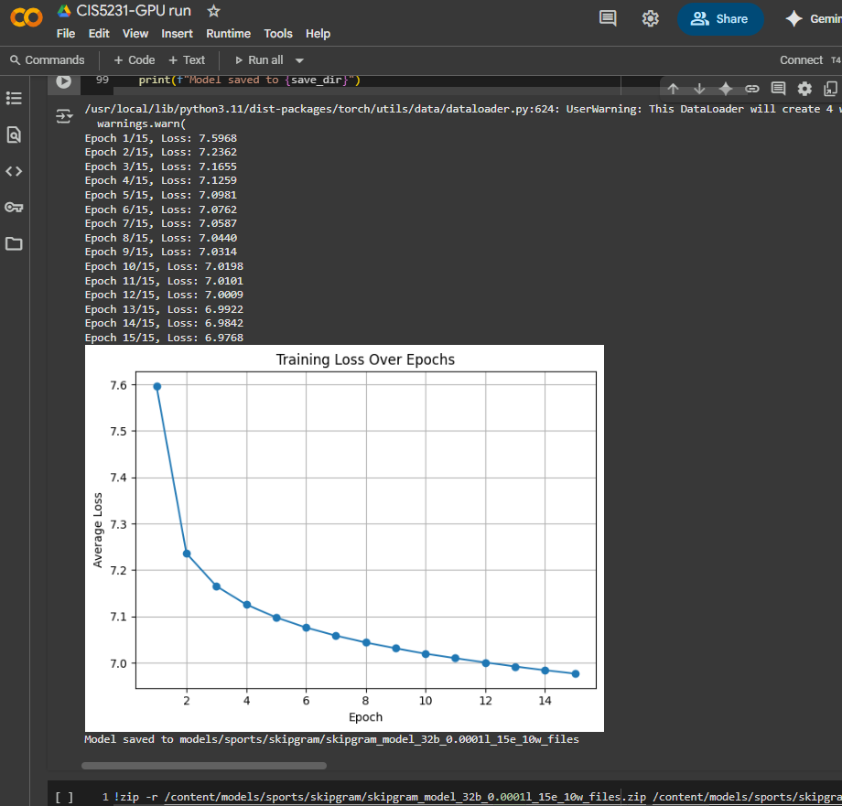

## Hyper-Parameter Tuning

All training and experimentation were run on seed 42 to prevent any unwanted variations.

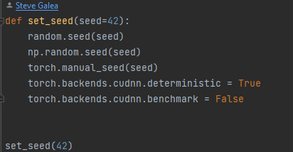

26 hyperparameter tuning experiments were run, 13 for SkipGram and 13 for CBOW. The following hyperparameters were experimented with:

* Batch sizes: 16 (CBOW only), 32, 64, 128, 256
* Epochs (including checkpoints): 10, 20, 30, 40, 50 or 100
* Window sizes: 2, 3, 4, 5, 10
* Learning rates: 0.0001, 0.001, 0.01, 0.05
* Models: cbow, skipgram

## Performance Monitoring

The models’ performance was measured through training loss. Models with the lowest training loss and at a converged state were considered to have finished training. All obtained Loss Plots are listed in the appendix. At each checkpoint, the training loss and vectors at that checkpoint are exported and saved locally.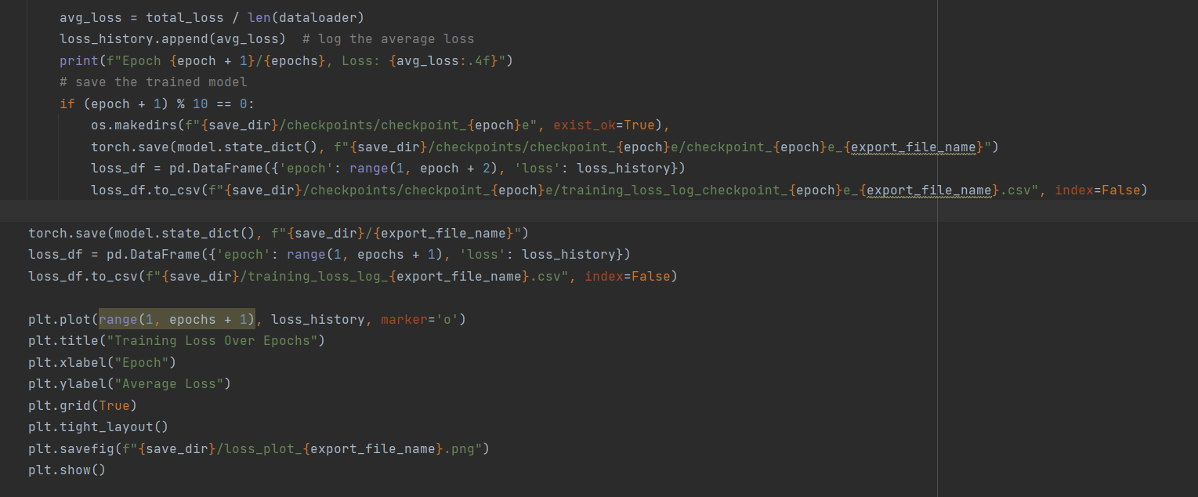

## Adaptation

To complete within a 2-3 hour training window on a CPU, one should lower the epoch count. Note, these were estimated, but should keep to a 2-3 hour window.

|  |  |  |  |  |
| --- | --- | --- | --- | --- |
| Model | Epochs | Learning Rate | Window size | Batch size |
| CBOW | 100 | 0.01 | 2 | 128 |
| SkipGram | 12 | 0.01 | 5 | 256 |

For CBOW, ~50 epochs were observed to fit in a 2-3 hour window, but for SkipGram, this took longer due to the more complex processing.

## Visualisation Techniques Used (4_tSNE_visualisation_and_analysis.py)

A training loss against the Epochs curve was used to determine if the model converged (e.g. **loss_plot_skipgram_model_256b_0.05l_10e_10w.pth.png**).

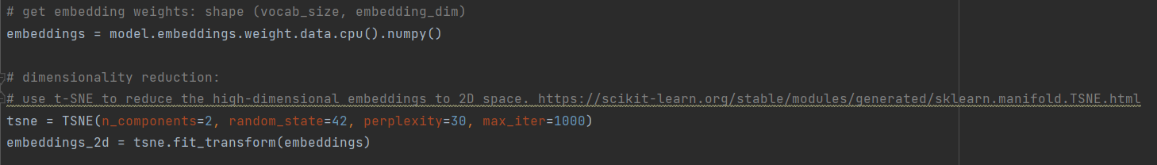

Also, a dedicated script for analysis was created **4_tSNE_visualisation_and_analysis.py**. In it one can input hyperparameters and specify which saved embeddings to analyse.

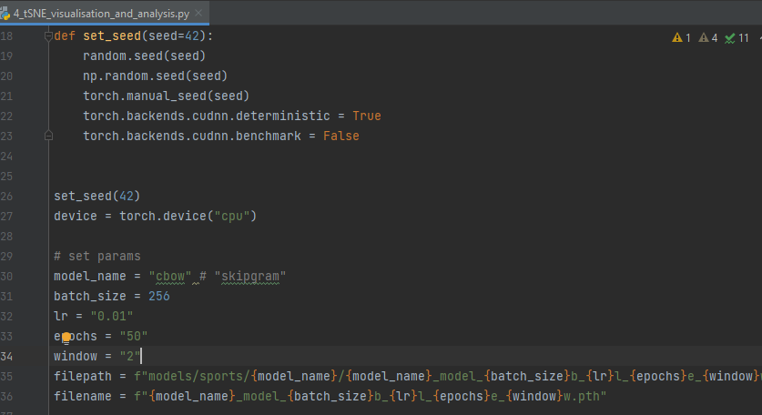

After loading the model’s embeddings at the last saved state, TSNE is applied to the embeddings.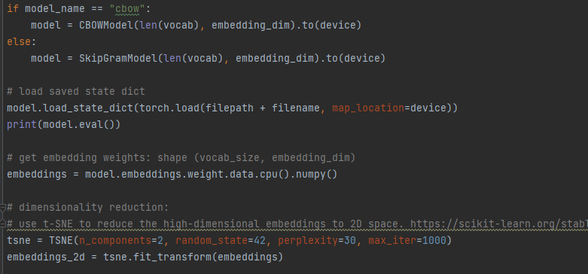

Also, for each model, all TSNE was used to reduce the high-dimensional embeddings of 10,000 words to a 2D space to visualise and plot any clusters (e.g. file **top_10000_tsne_word_embeddings_skipgram_model_256b_0.05l_10e_10w.pth.png**). To supplement this, a dedicated CSV file with all coordinate and word data was created to describe points and clusters (e.g. **tsne_embeddings_skipgram_model_256b_0.05l_10e_10w.pth.csv**)

In addition, the following categories were manually created to have a more manageable visualisation to interpret. The conditions for the categories and the words were chosen intuitively and were derived from the dataset.

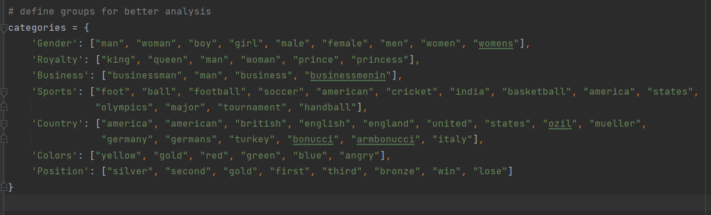

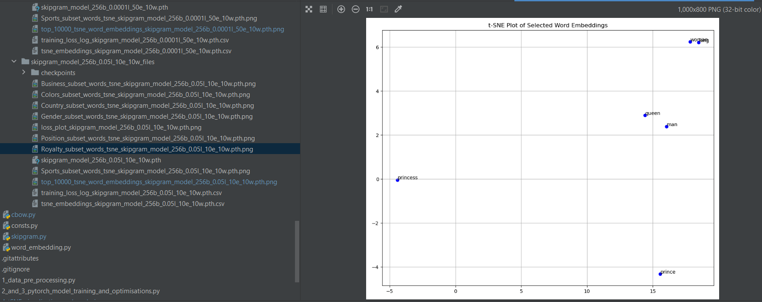

Figure .: Example plot showing similar/opposite words being plotted in a space.

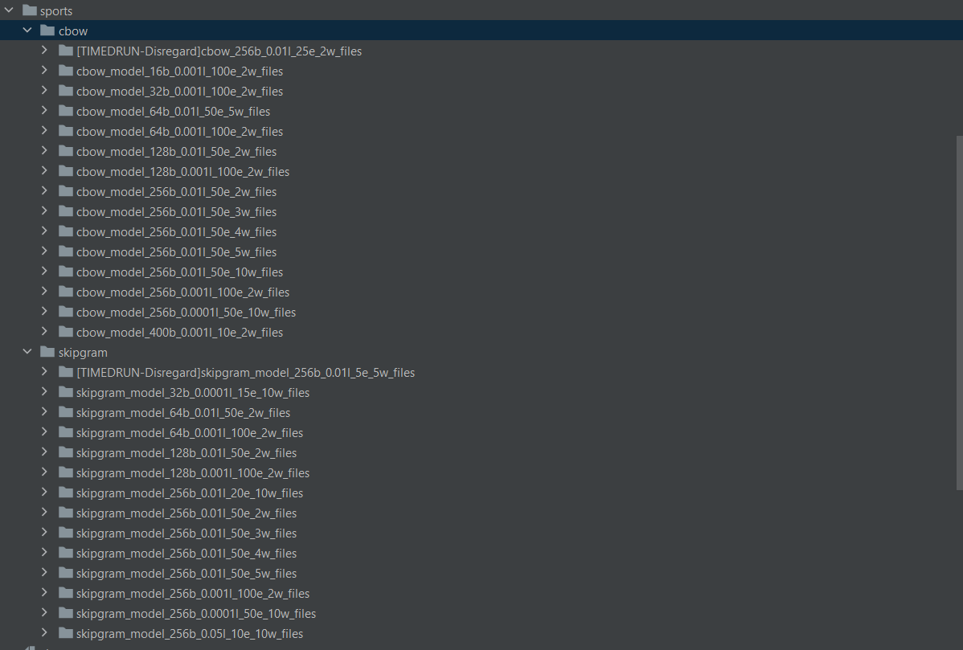

Figure .: The figure shows the full list of experiments conducted available on Github [SteveGalea/CIS5231](https://github.com/SteveGalea/CIS5231)

# Discussion of results

* The full plots, visualisations and results can be located on Github [SteveGalea/CIS5231](https://github.com/SteveGalea/CIS5231).
* All the models converged successfully, and both models got fitted on tSNE without issue and produced clusters of sorts. Most notably, Skip-gram models with 3-5, and 10 windows produced better clustering than CBOW models.
* Consistent with the Literature Reviewed, CBOW was quicker than Skip-gram. Increasing window size made Skip-gram training slower and more complex.
* Refer to the Appendix **Convergence Plots & tSNE embeddings** for specific model plots, or access GitHub to view specific images and results by the model name.

Results will be discussed as follows:

1. Effect of the number of epochs
2. Effect of learning rate
3. Effect of batch size for Skip-gram and CBOW
4. Effect of window size on Skip-gram and CBOW
5. Skip-gram generic results & clusters overall vs CBOW generic results & clusters overall
6. A further analysis per category on a particular model

Effect of the number of epochs

While it is true, more epochs mean convergence should occur, at some point, the models reached a minimum in the training loss, where the average loss did not significantly change as much from one epoch to another.

Effect of learning rate

Smaller learning rates in skip-gram (batch 64, window size 2) seemed to produce more distinctive and spread out clusters (image on the left visually has more clusters), while that of 0.001 has a large central cluster, but many small ones around it.

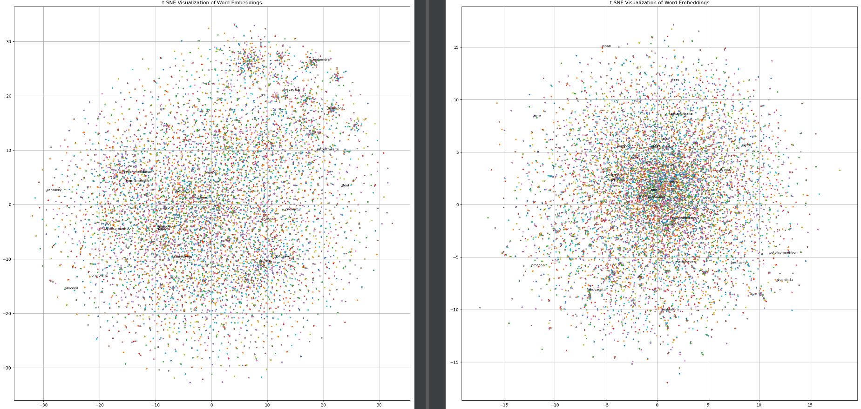

Figure .: Skipgram 0.01 learning rate (left) vs Skipgram 0.001 learning rate

The same thing occurs for CBOW (batch 256, window size 2)

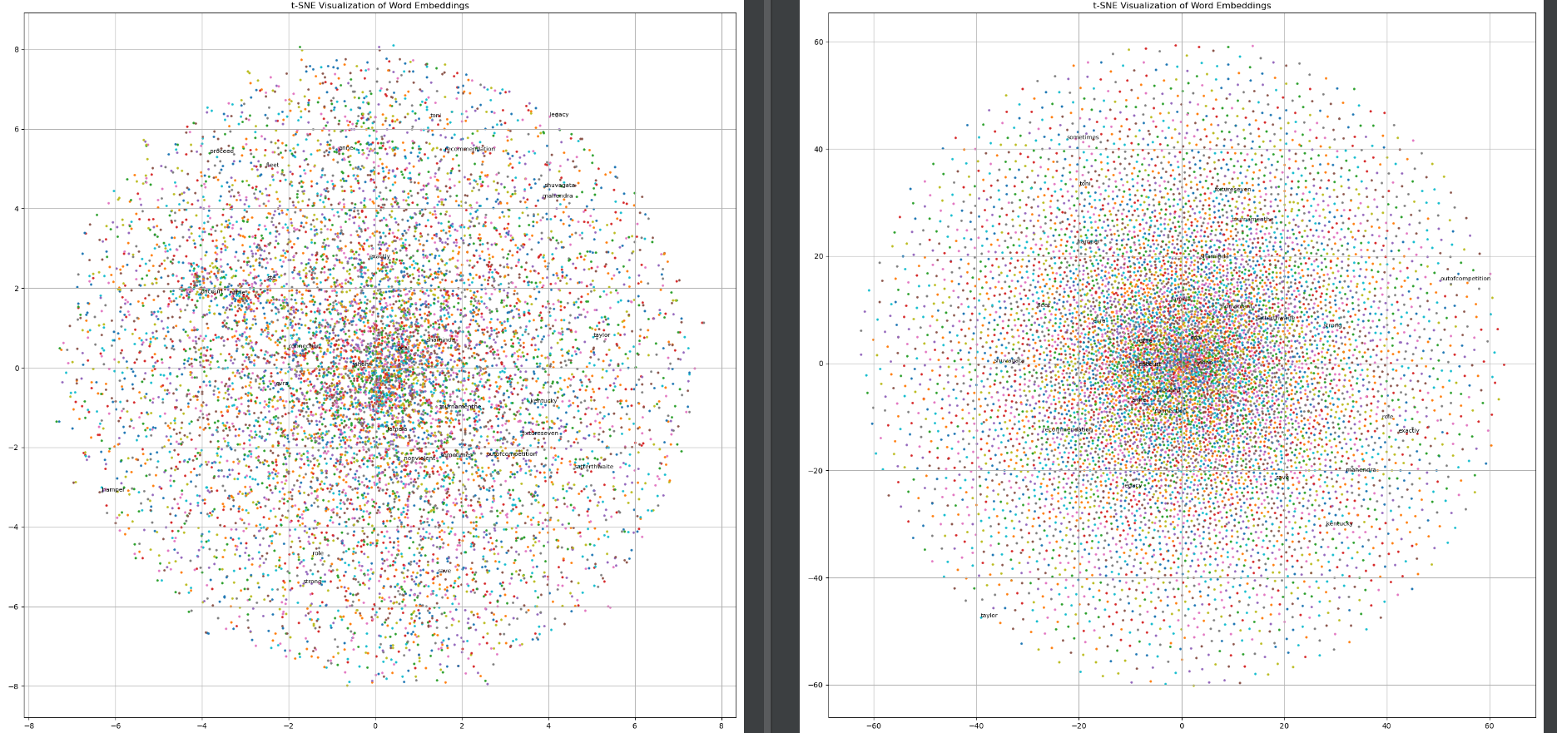

Figure .: CBOW 0.01 learning rate (left) vs CBOW 0.001 learning rate (right)

Effect of batch size

Smaller mini-batches of size 16 for CBOW model (learning rate 0.001) over a window of 2 **cbow_model_16b_0.001l_100e_2w_files** did seem to provide better clusters than 32, 64, 128 and 256 (**cbow_model_256b_0.001l_100e_2w_files)** and cbow_model_64b_0.001l_100e_2w_files when it came to tSNE, as below.

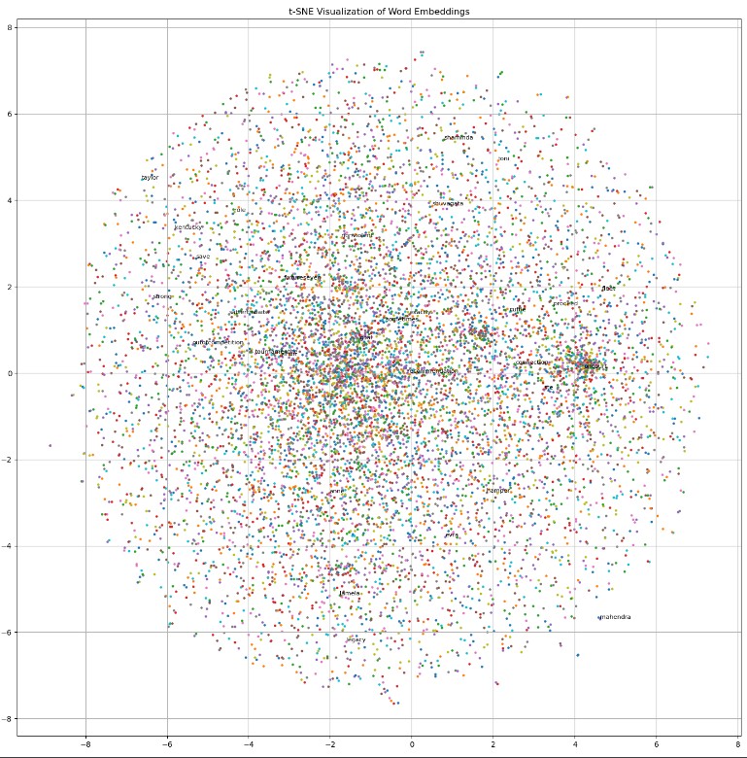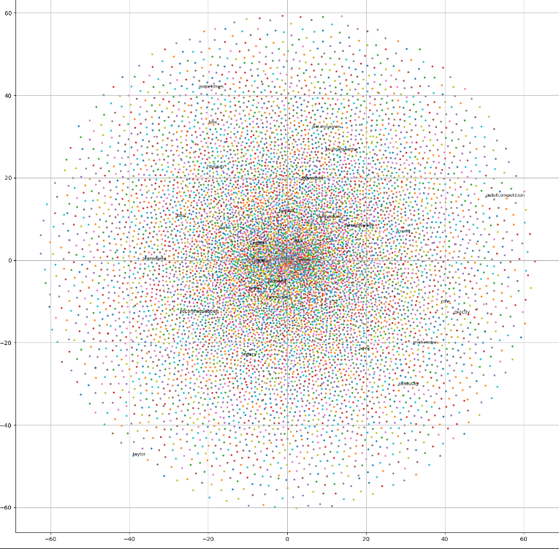

Figure .: CBOW 32 batch size(left) vs CBOW 256 batch size (right)

Also, smaller batch sizes allowed quicker convergence 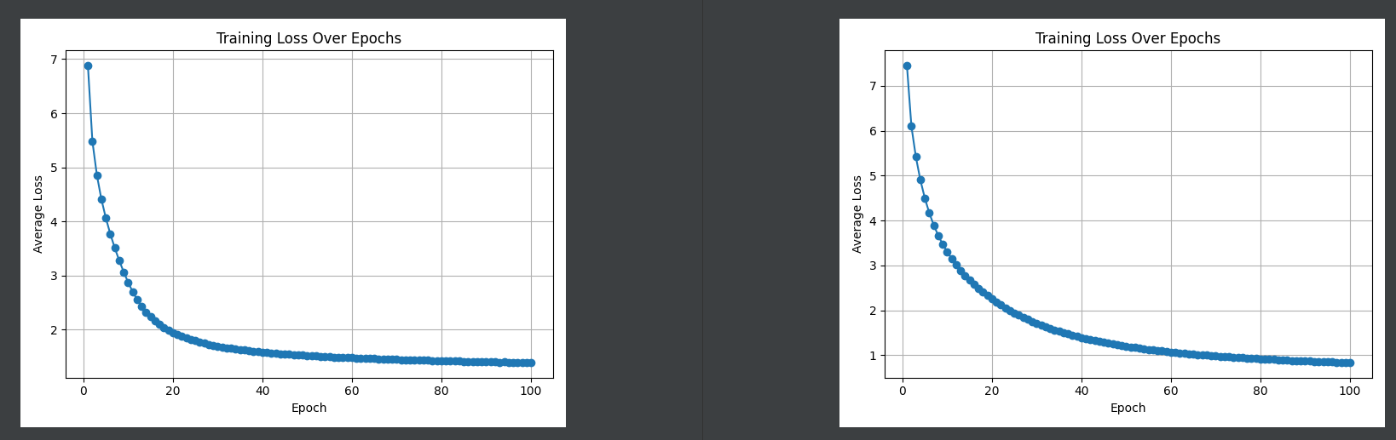

Figure .: CBOW 16 batch size (left) vs CBOW 256 batch size (right)

For skip-gram, smaller batch size made the tSNE embeddings fit within a bigger range on the x- and y-axis.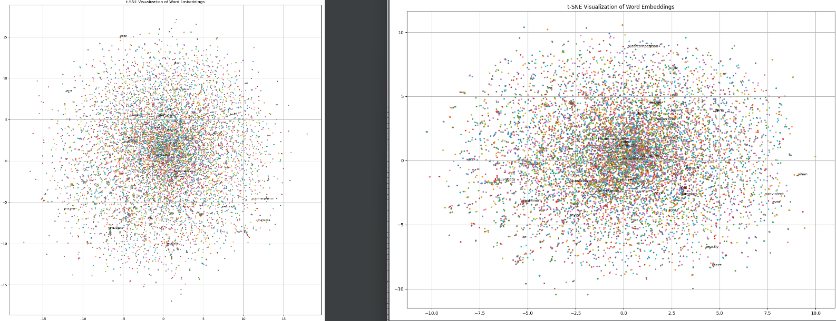

Figure .: SkipGram 64 batch size (left) vs SkipGram 256 batch size (right)

A bigger batch size allowed for a smaller average loss value.

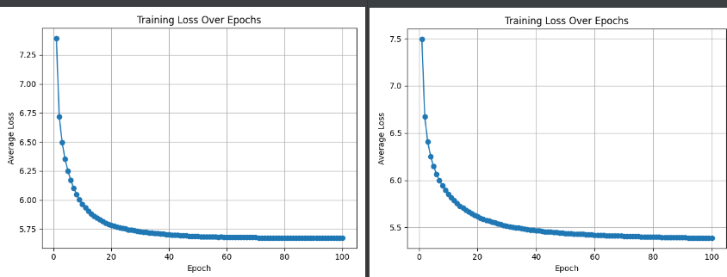

Figure .: SkipGram 64 batch size (left) vs SkipGram 256 batch size (right)

Effect of window size

With a larger window size (> 2), Skip-gram models seemed to produce more distinguished clusters, as below: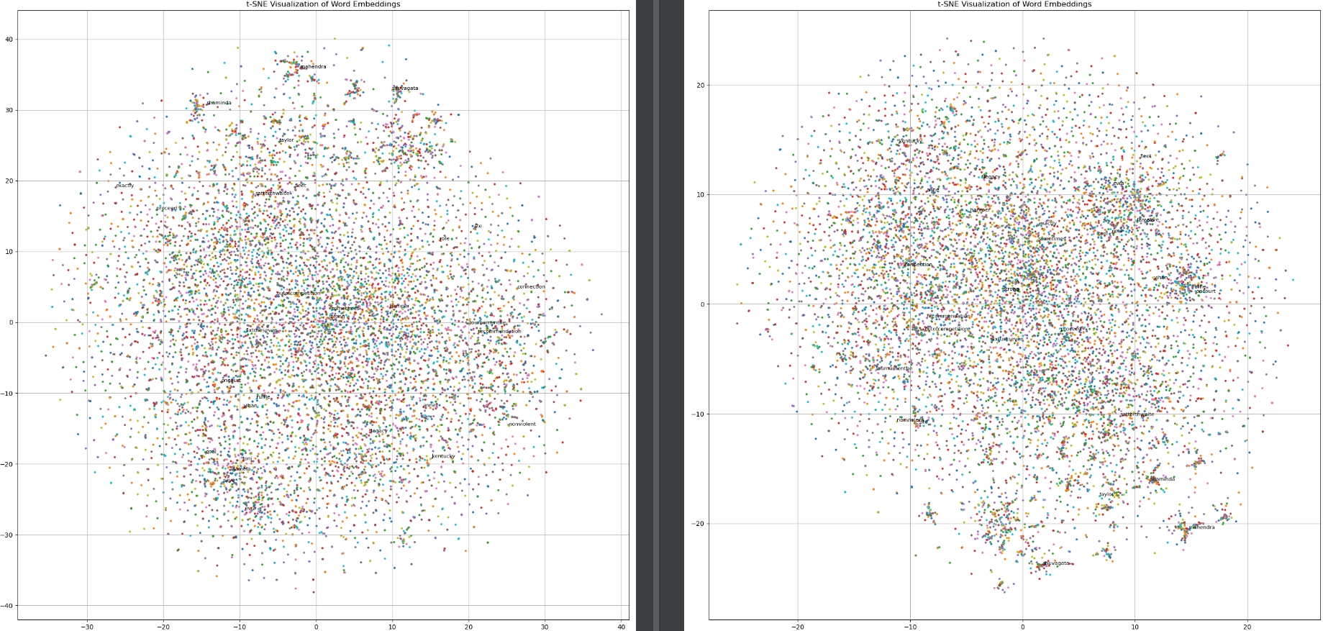

Figure .: Skip-gram (batch 256, learning rate 0.01) window size 2 (left) vs Skip-gram (batch 256, learning rate 0.01) window size 5 (right)

Same window size (10) below, however, this tests extremes, a small minibatch of 32 with a small learning rate of 0.0001 produces a big range of values, with a large central cluster and some distinct clusters at the edges. A large batch of 256 with a larger learning rate of 0.05 produces smaller data ranges, and 2 large clusters at the centre.

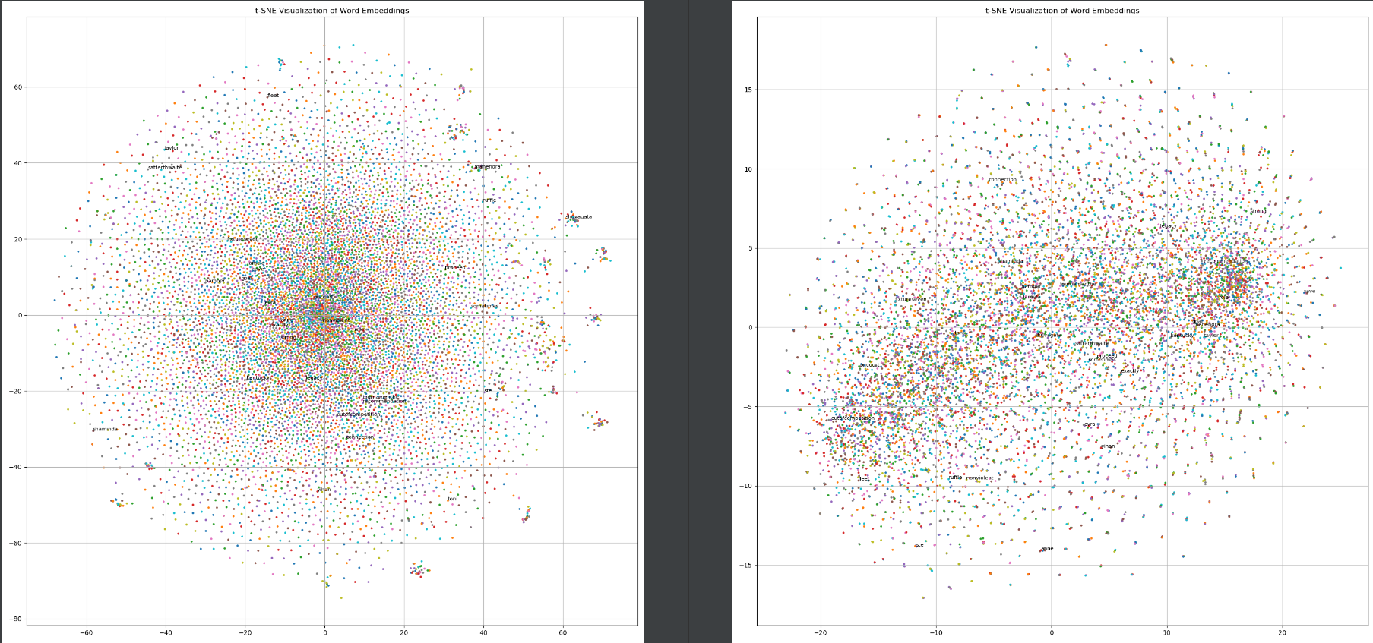

Figure .: Skip-gram (batch 32, learning rate 0.0001) 10 window size (left) vs skip-gram (batch 256, learning rate 0.05) window size 10 (right)

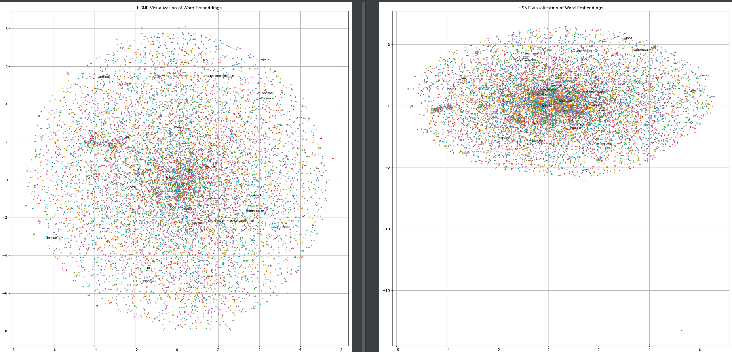

Figure .: CBOW (batch 256, learning rate 0.01) window 2 (left) vs window 5 (right)

The window size doesn’t seem to affect CBOW. The same x-, y-axis ranges are there, and no clusters are immediately visible with the window.

Skipgram generic results & clusters overall vs CBOW generic results & clusters overall

* Overall, for Skipgram, increasing the window size immediately distinguishes certain clusters. However, for CBOW, decreasing the batch size directly affects getting distinguished and separated clusters.

A further analysis per category

To analyse further by category, **consider Skip-gram (batch 256, learning rate 0.01), window size** **2**.

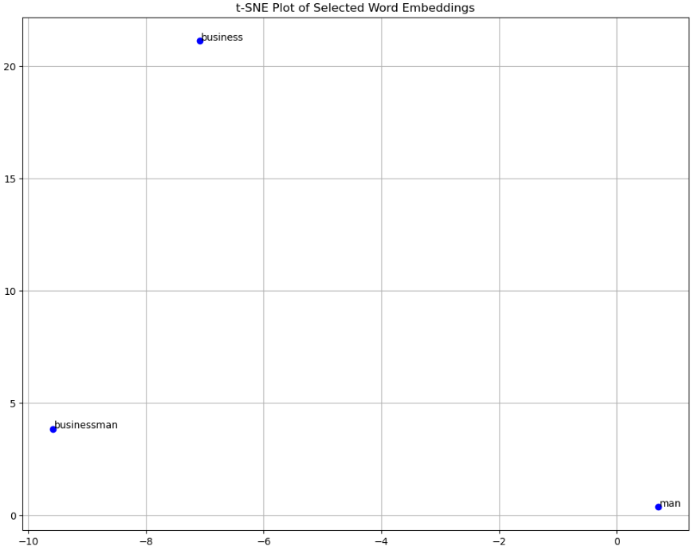

Figure .: The business category, for **Skip-gram (batch 256, learning rate 0.01), window size** **5**.

In the figure above, it can be seen that skip-gram makes a clear distinction between the three words. But this alone is not enough to deduce the effectiveness of the word embeddings.

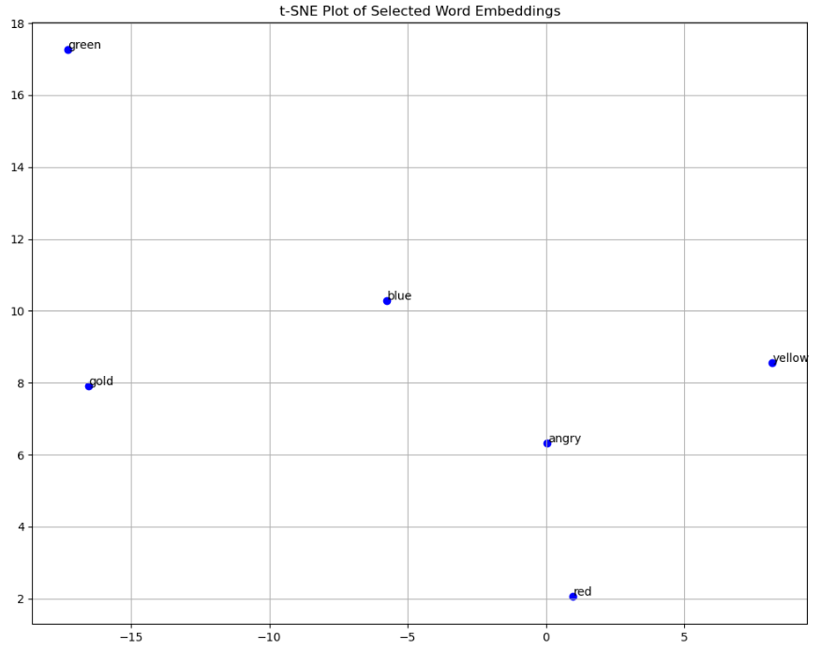

Figure .: The colour category for **Skip-gram (batch 256, learning rate 0.01), window size** **5**.

Different colours above were put for this category, and “angry” was inserted in. Anger is often associated with “seeing red”. It was interesting that of all the words, “angry” seems closest to the “red” colour.

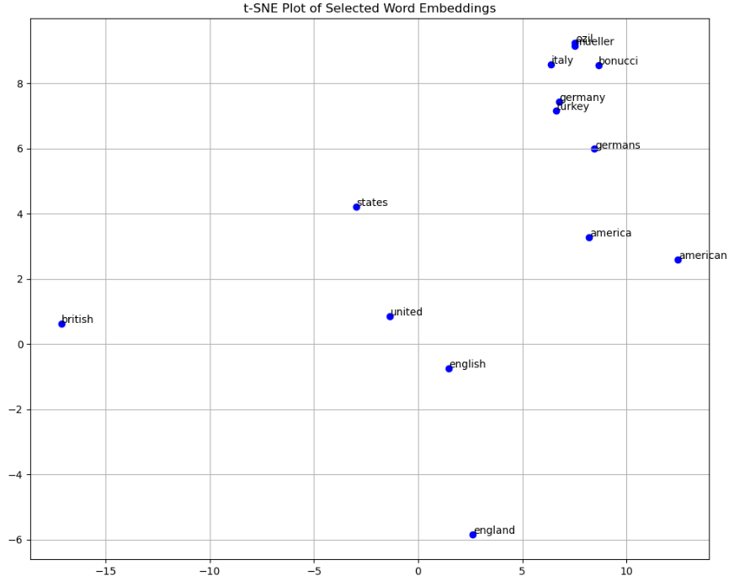

Figure .: The country category for **Skip-gram (batch 256, learning rate 0.01), window size** **5**.

The country category contained keyword pairs related to countries and 3 football players. Ozil is half german, half turk and was a German National football player, Mueller is a German National football player and Bonucci is an Italian national player.

It is interesting to see that “united”-“states”, “America”-“American”, “English”-“England”, “united”-“British”, “united”-“english”, “Germany”-“germans” for the countries are all immediate neighbours. “ozil” and “mueller”, two star german players have very close vector embeddings, and have “bonucci” close to them. “Italy” and “bonucci” are also similarly close to each other. This shows that meaningful clusters were made.

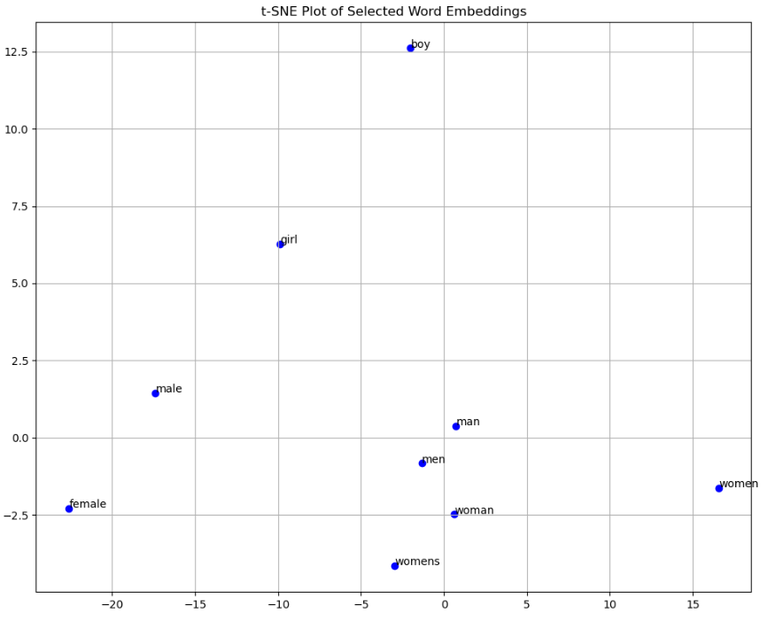

Figure .: The gender category for **Skip-gram (batch 256, learning rate 0.01), window size** **5**.

The gender category contains the same thing. “man” and “men”, “woman” and “womens” are close to each other. Opposites, or words with completely different meaning, seem to have separation like “boy” and “girl” or “male” and “female”.

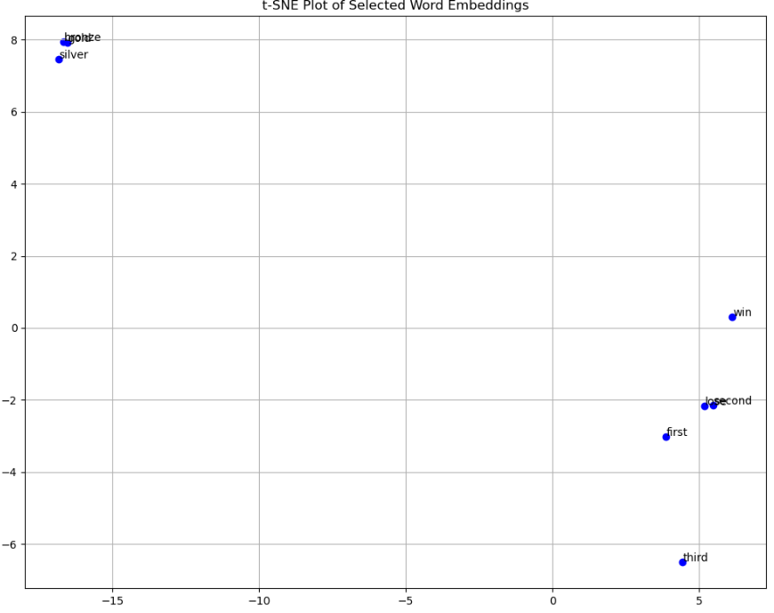

Figure .: The position category for Skip-gram (batch 256, learning rate 0.01), window size 5.

As a reminder, this category contained 3 similar words “gold”, “silver”, “bronze” (which are well grouped up in the upper left corner), 2 opposite words “win”, “lose”, and “first”, “second”, “third”.

Clearly from the image above, skip-gram distinguishes the metals “gold”, “silver”, “bronze” from the first second and third positions. “first” is interestingly not associated with “win”, however, “lose” is closely related to “second”. “third” is in a plot of its own.

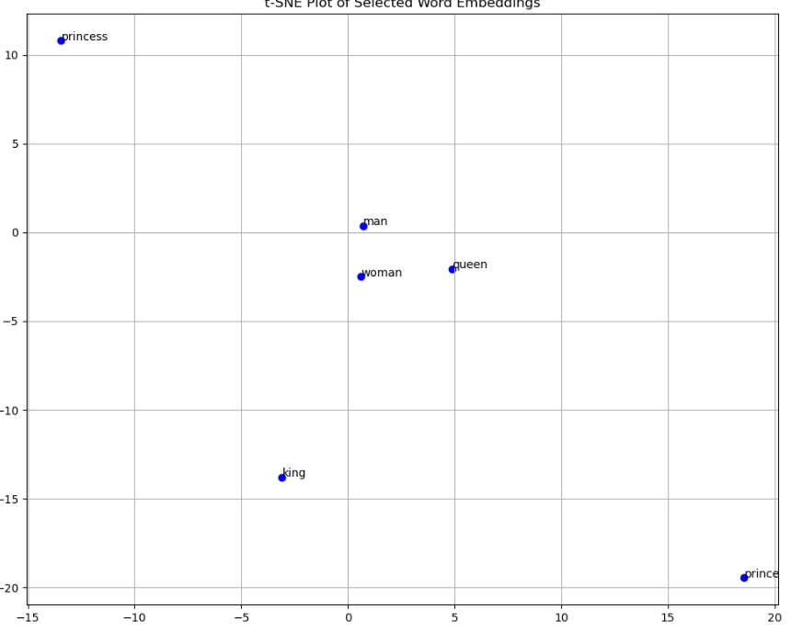

Figure .: The royalty category for Skip-gram (batch 256, learning rate 0.01), window size 5.

The skip-gram model above seems to be focusing on defining opposites for this dataset. “man” seems to be singled out and nearer to “woman” than “king”. This could be because of dimensionality reduction, so the association may be clearer at higher dimensionality, or because of the shared “man” word in “wo”-“man”. “woman” and “queen” are close to each other.

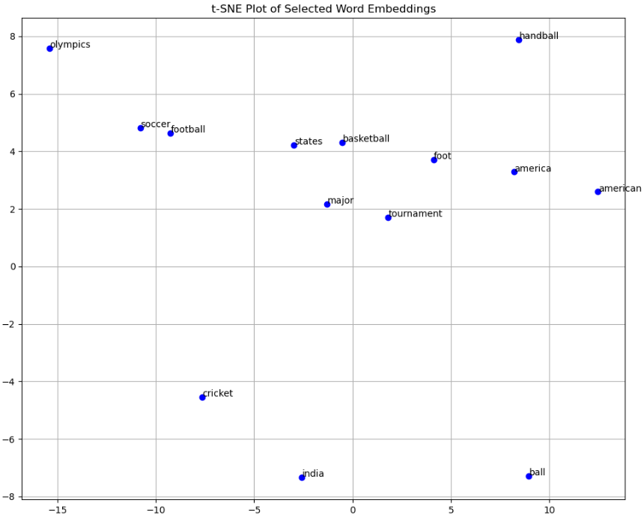

Figure .: The sport category for Skip-gram (batch 256, learning rate 0.01), window size 5.

The final category analysed is sports. “America”-“American”, “soccer”-“football”, “states”-“basketball”, “immediately seem to be clustered together. “cricket”’s closest neighbour in the plot is “india”, attributed possibly to the popularity of sports articles published in the country. “foot” and “ball” seem separated despite being closely related to “football”.

# Challenges Encountered

* Hyperparameter optimisation was performed using both CPUs and GPUs offered by Google Colab. However, due to time constraints, extensive tuning/hyperparameter optimisation was not possible.
* Establishing the right epoch size/batch size/context window size proved to be a challenge
* Interactive tSNE plots (using plotly package) and kNN visualisations were planned. Due to the size of the vocabulary and hardware requirements, this was not achieved, and resulted in errors
* Evaluating the best-performing model was also a challenge, as consistent and meaningful comparison metrics were difficult to establish.

# Possible Enhancements/Further work

* Feed larger datasets as per the literature review (6 billion) and use benchmark datasets
* Decrease the epoch count
* Better data preprocessing regimen
  + Treat noise better and remove highly common words
* Make use of different models as GloVe or ELMo
* Make use of a different optimiser, like Adagrad, used by Mikolov et al. [4]
* Make use of a different loss function, instead of CrossEntropyLoss
* Make more use of GPUs
* Further hyperparameter experimentation:
  + Mini-batches can be made smaller for CBOW
    - Assess with a larger dataset if this separates clusters better
  + Further window sizes for skip-gram
    - Assess with a larger dataset if this separates clusters better
* Analyse quality of embeddings through word similarity and analogy evaluation, using the same datasets as the literature
* Use cluster quality metrics
* Use kNN to visualise tSNE clusters
* Interactive tSNE plots
* Analyse polysemy and homonymy

# Convergence Plots & tSNE embeddings

Next page

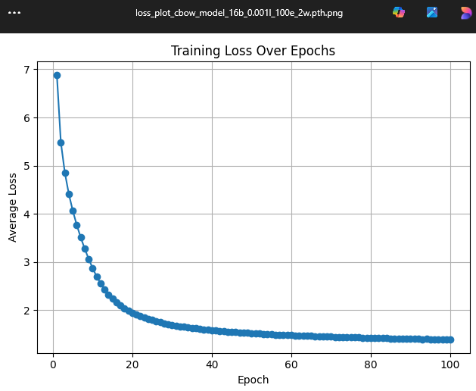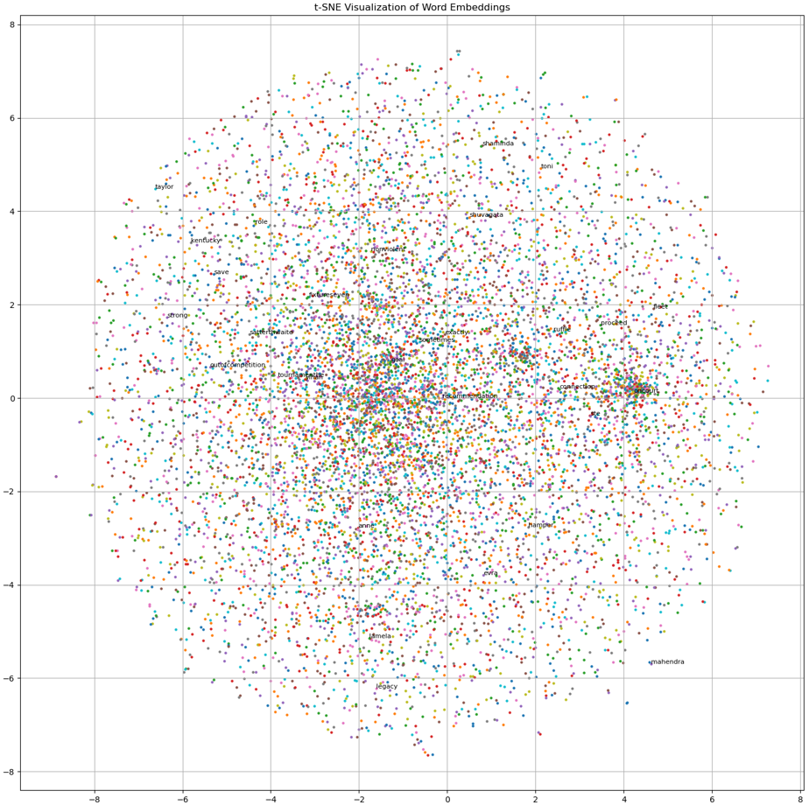

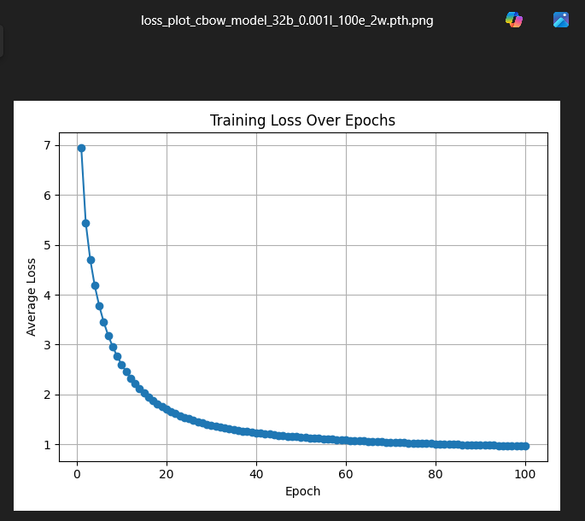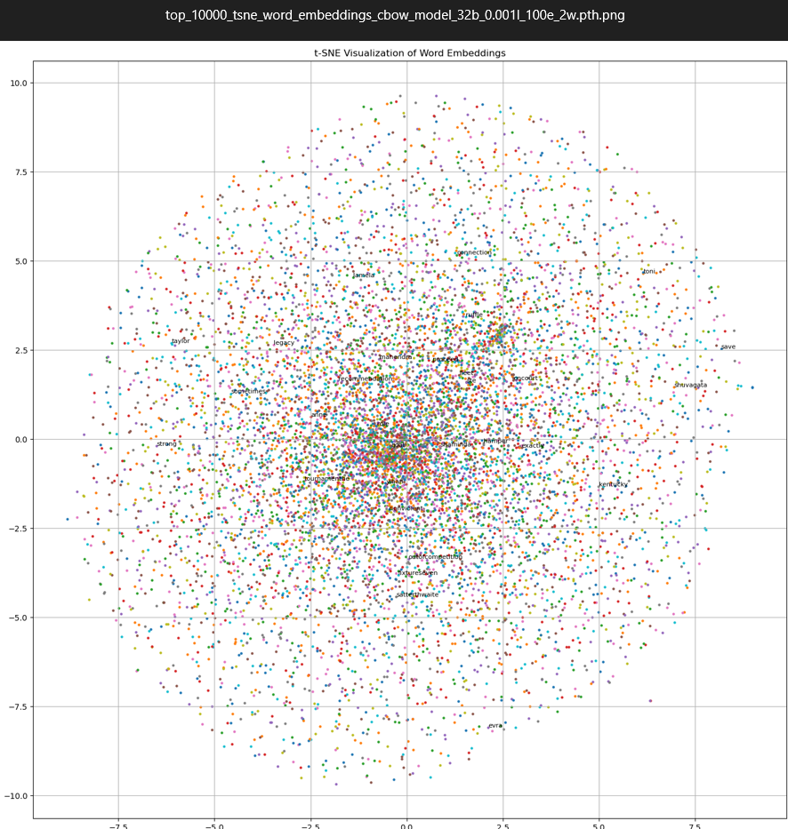

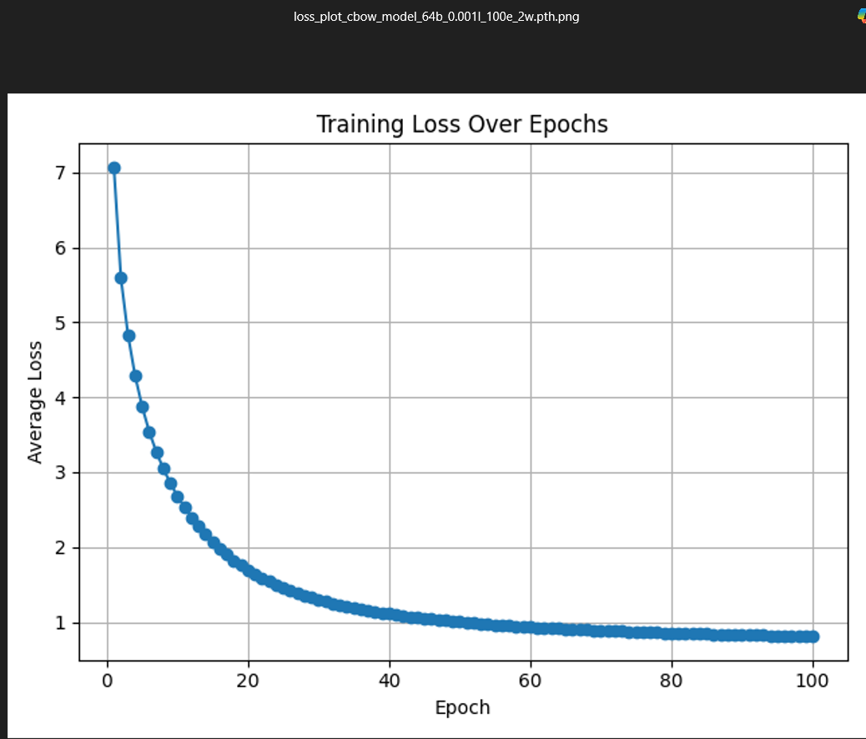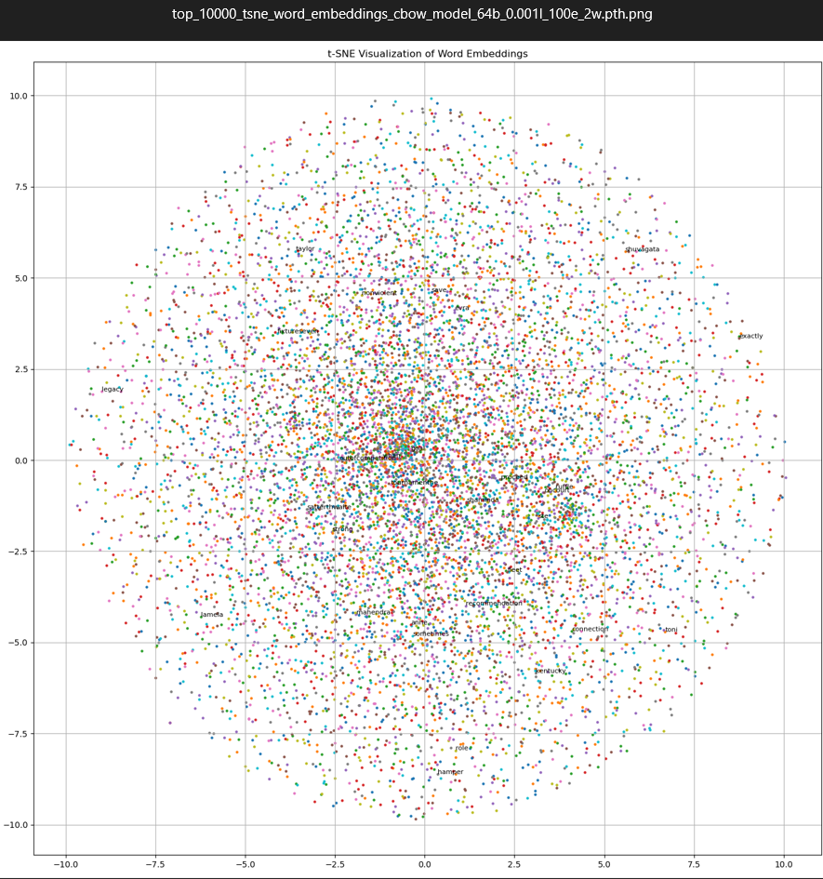

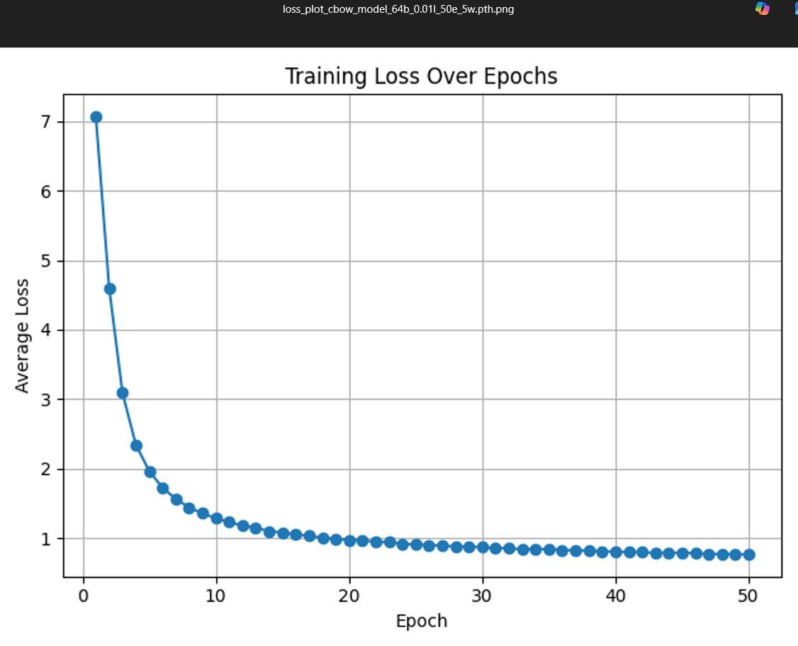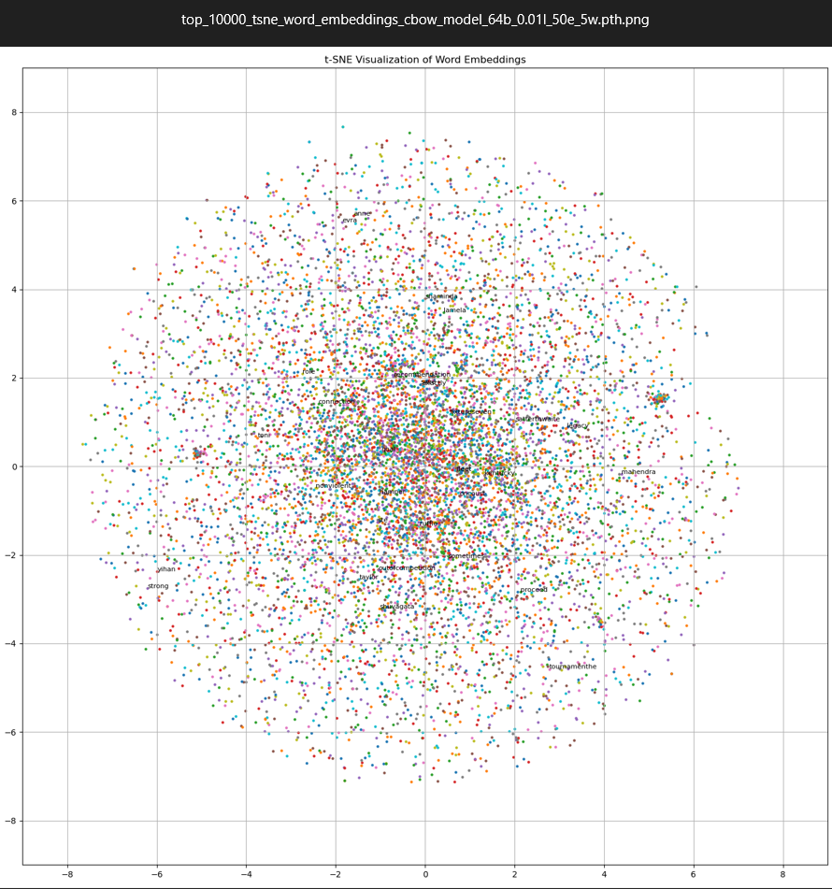

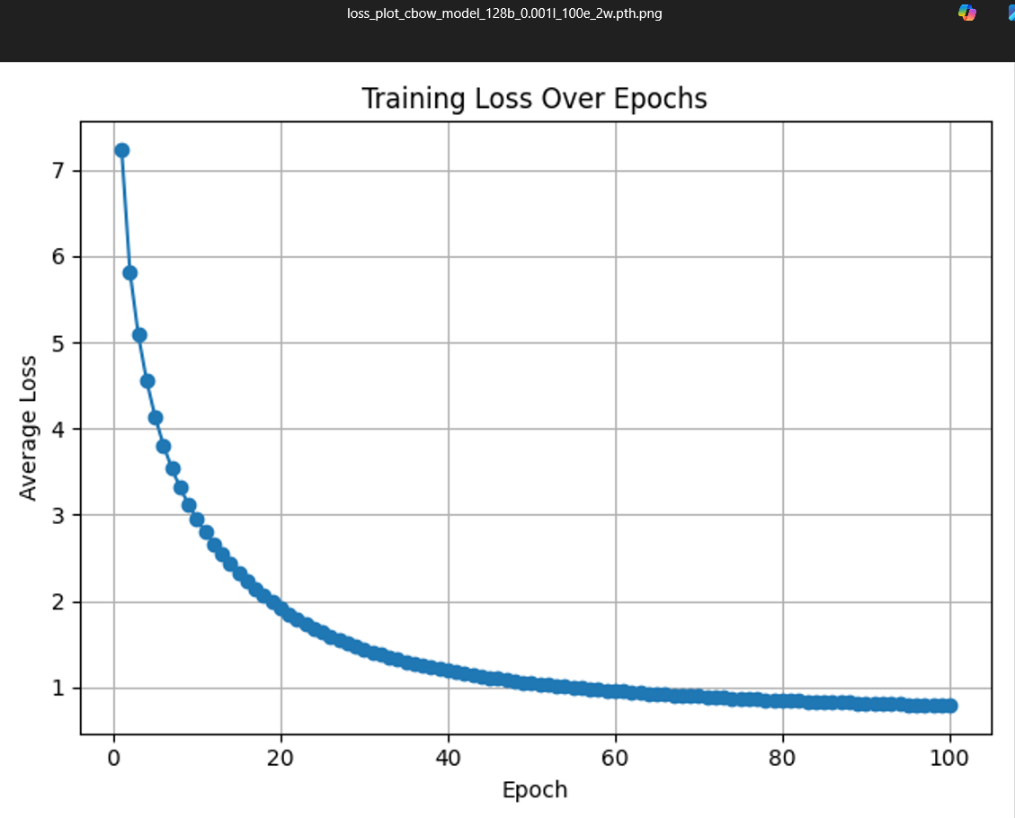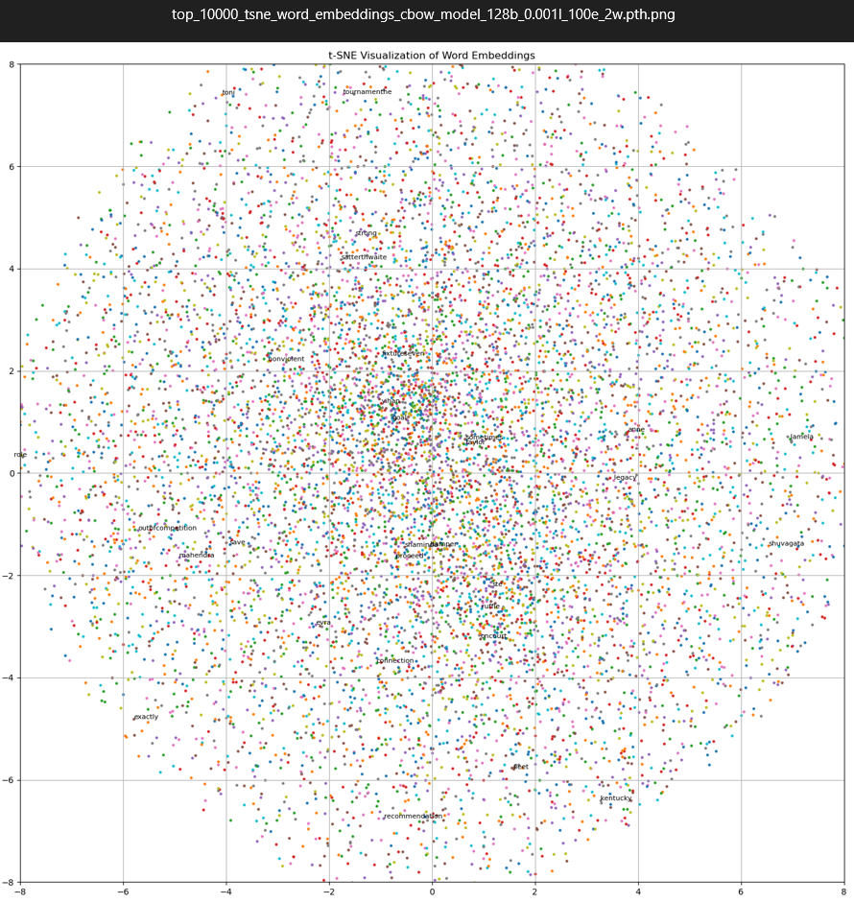

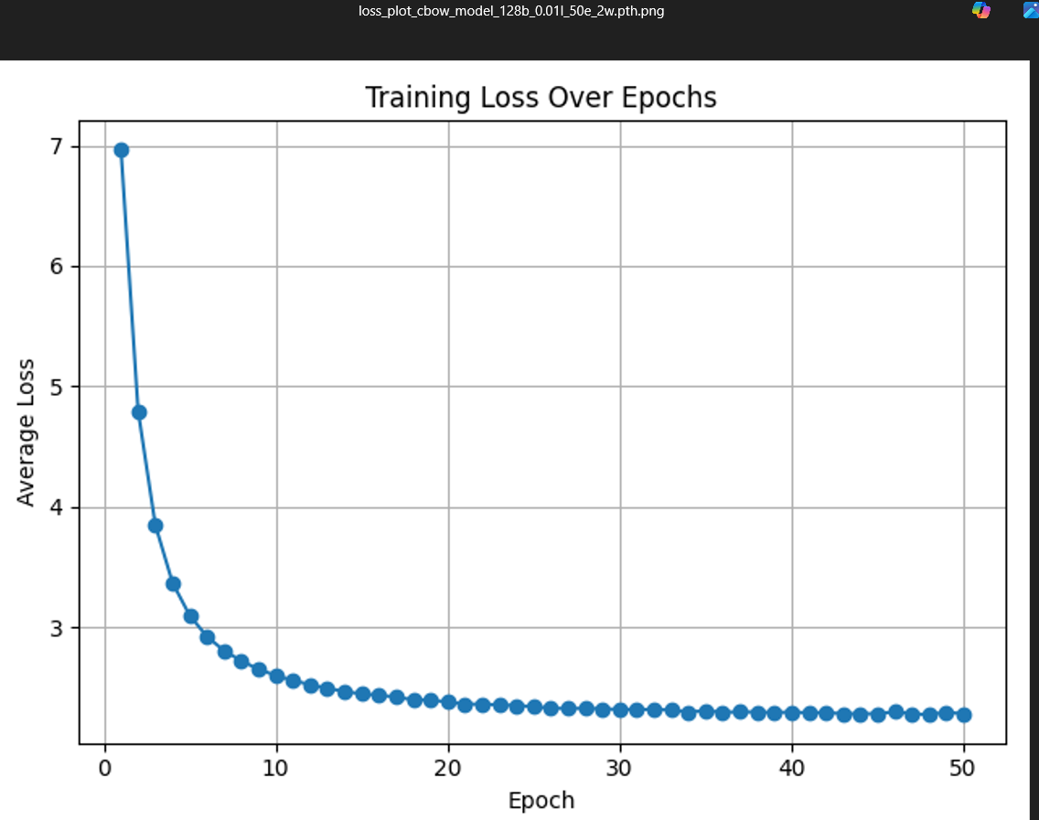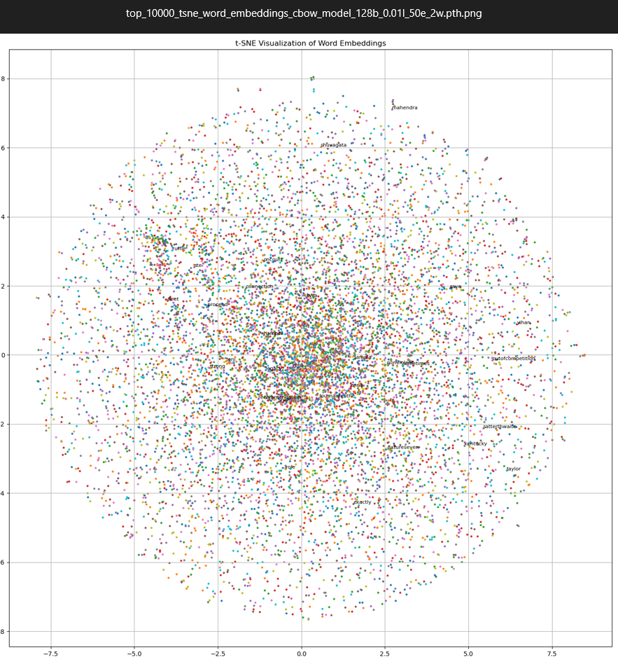

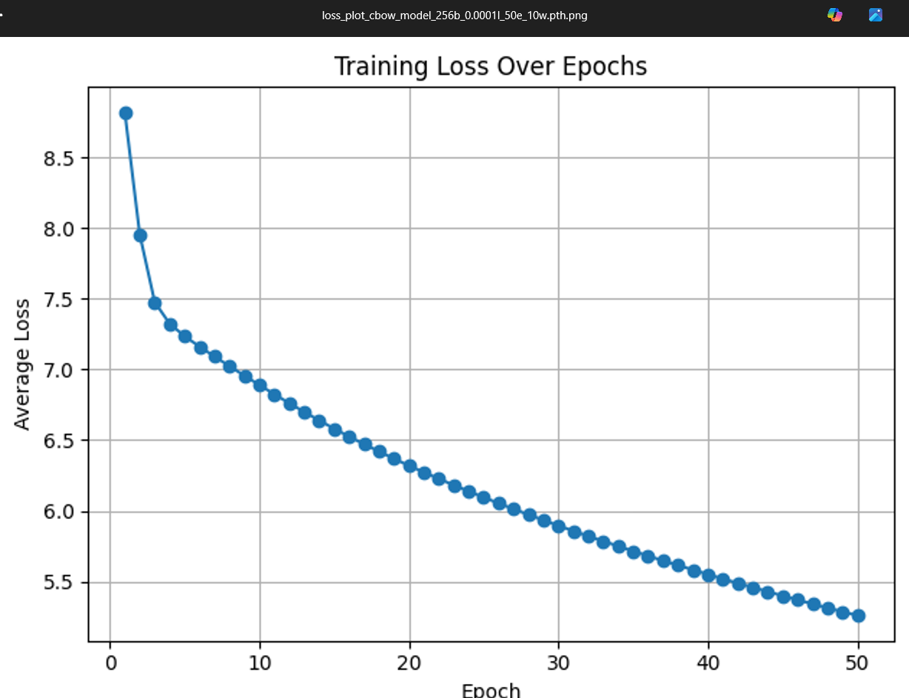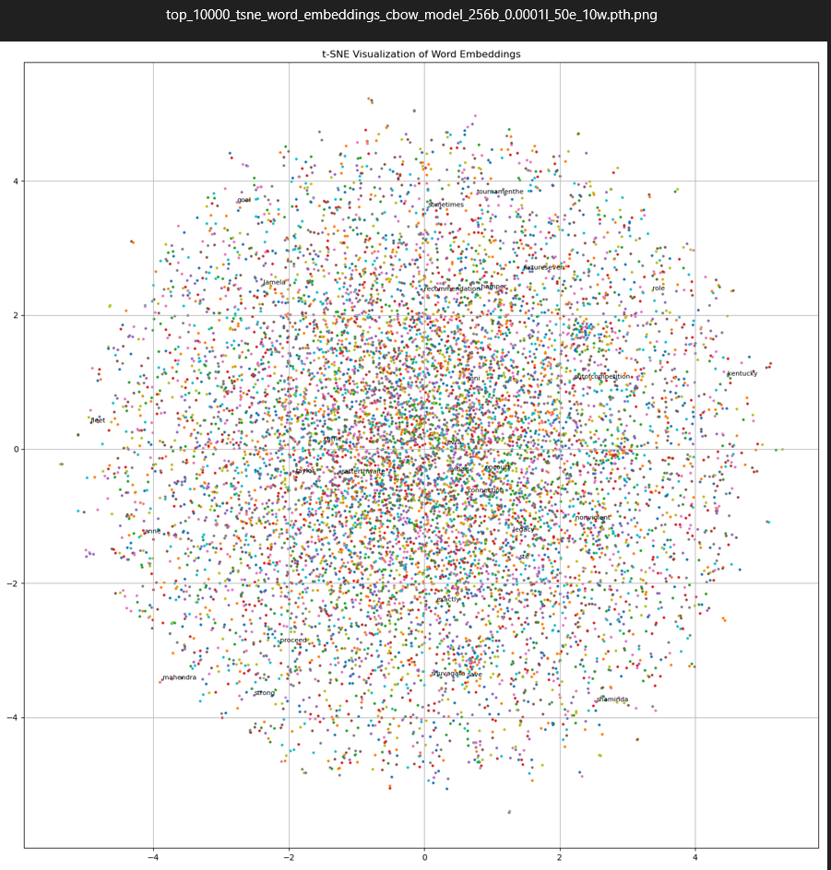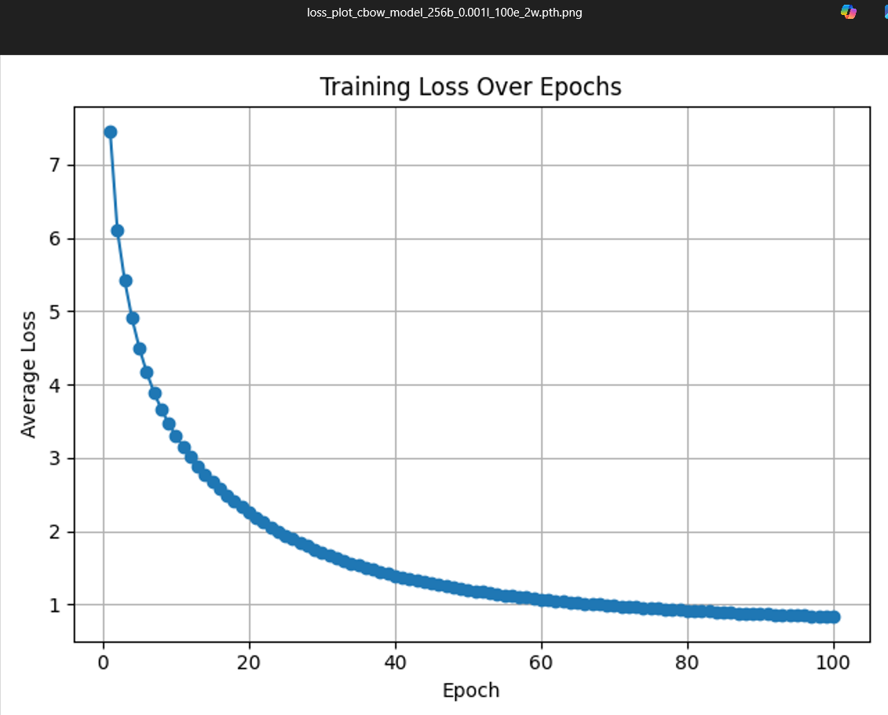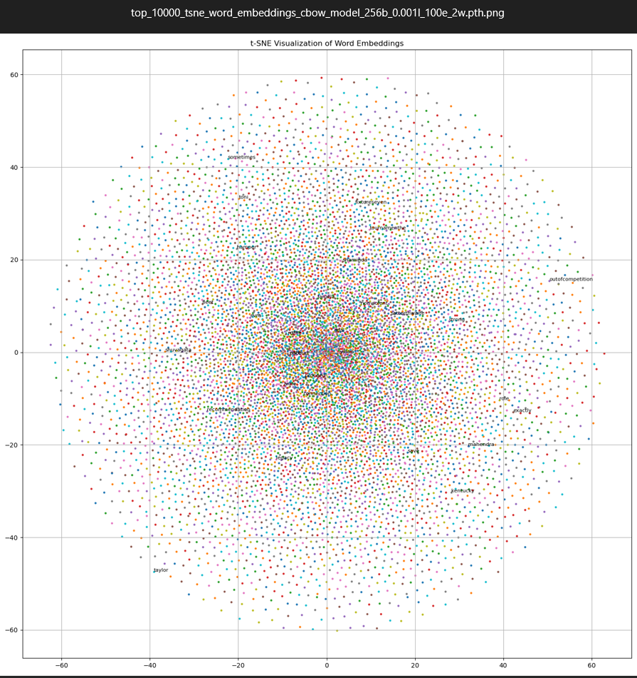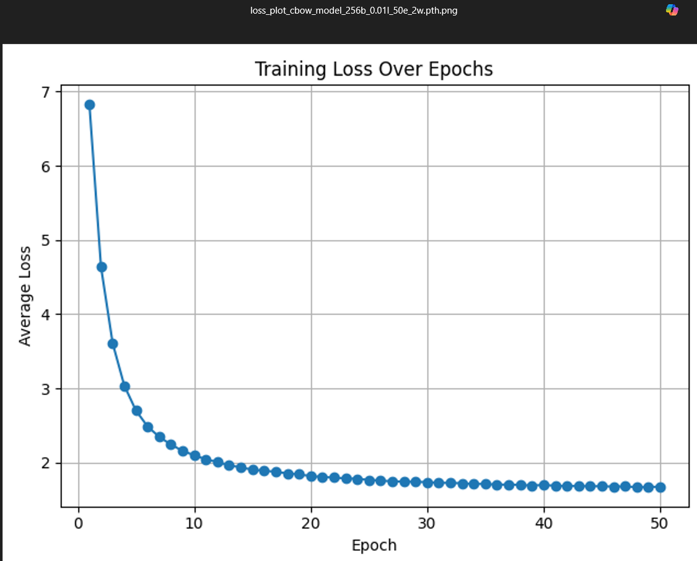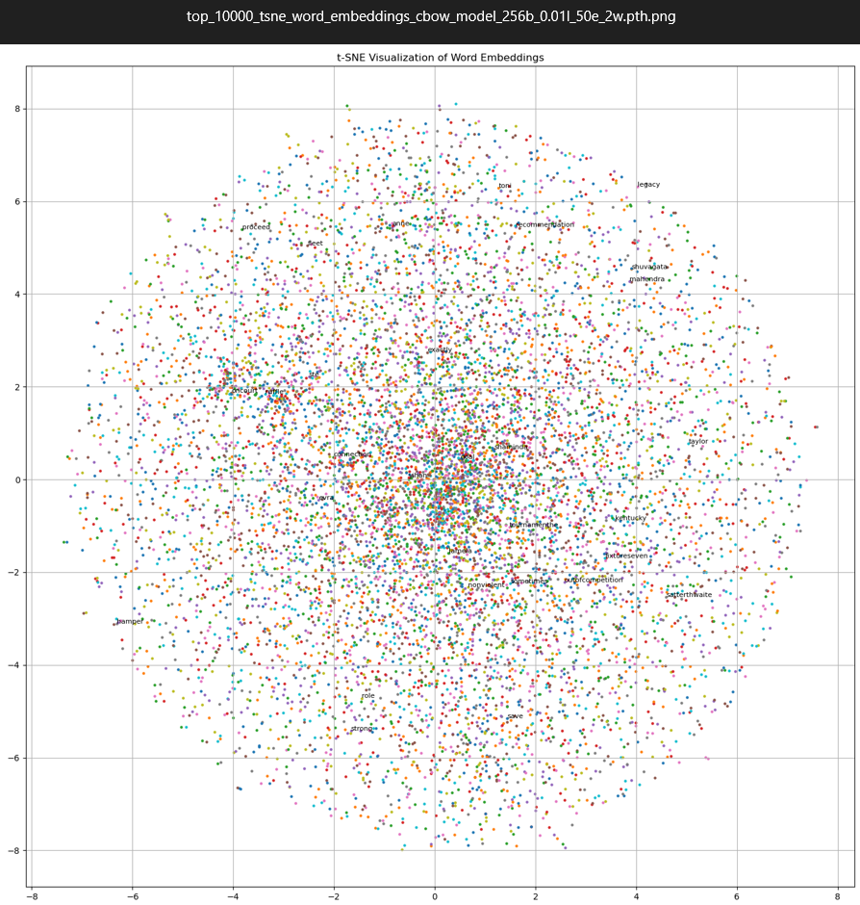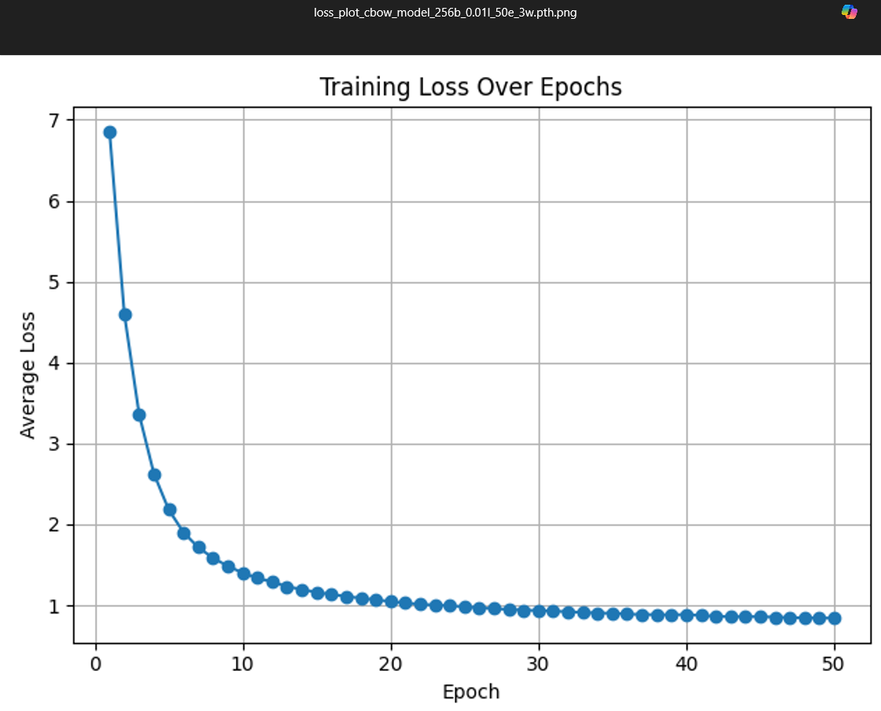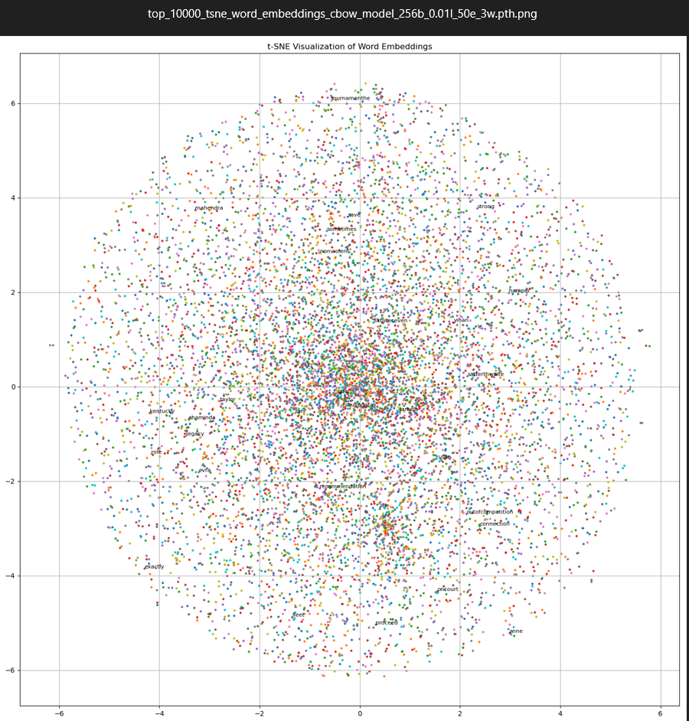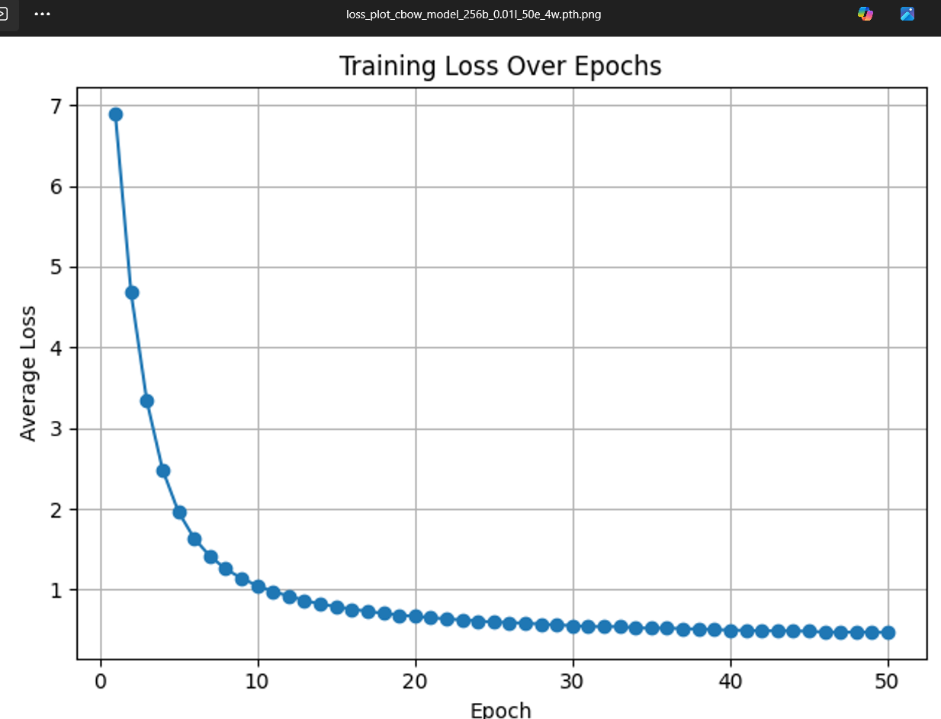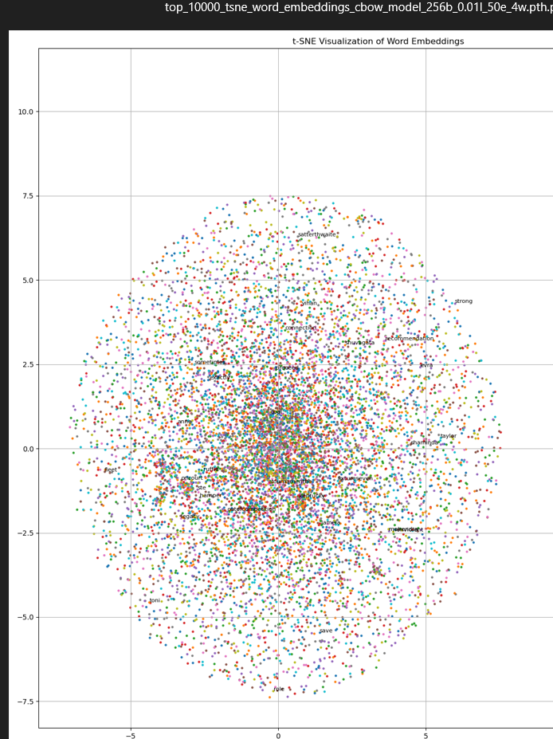

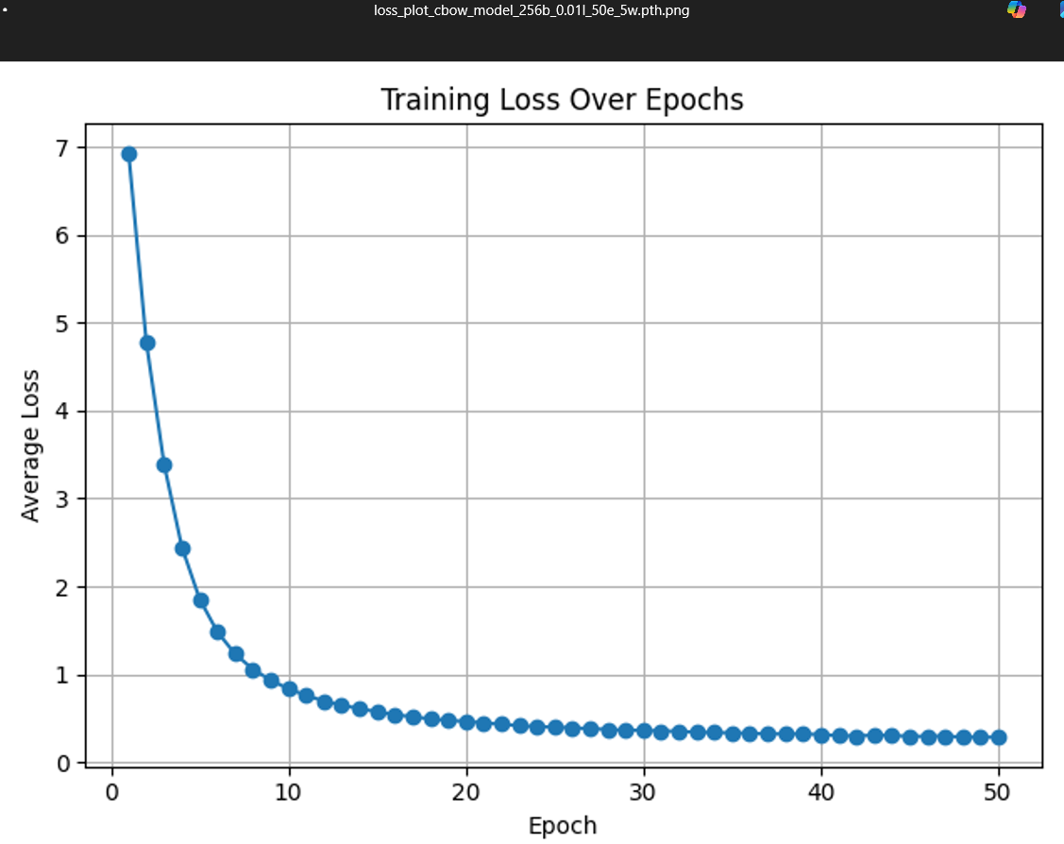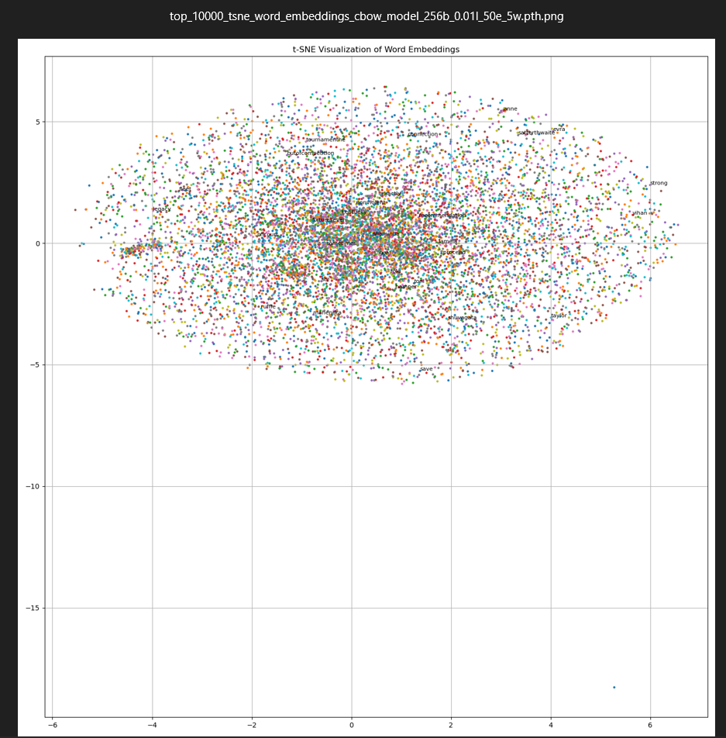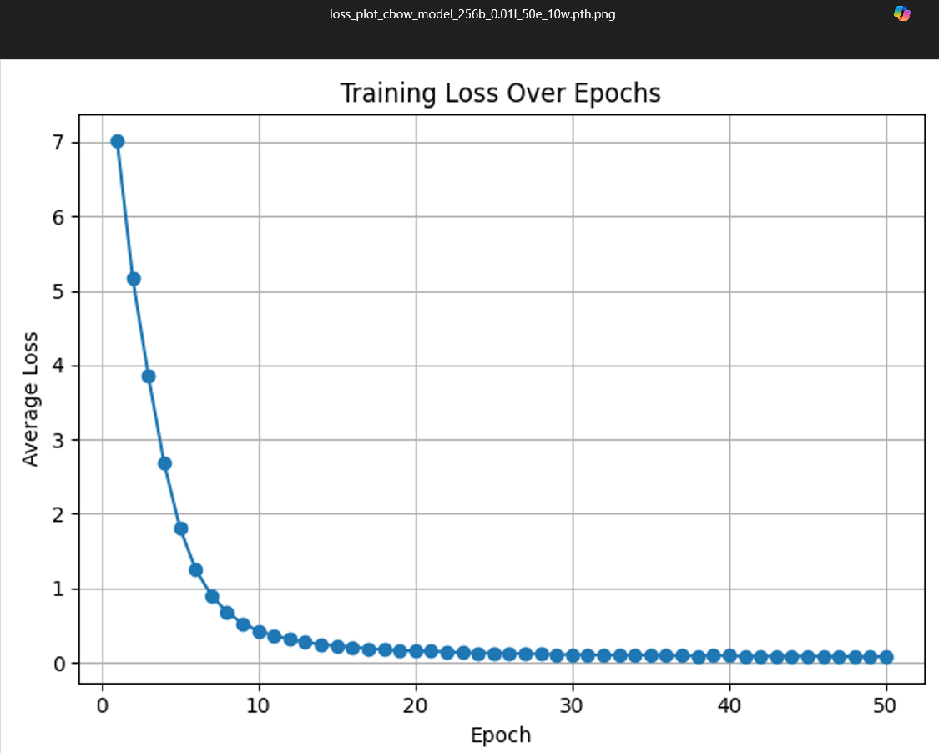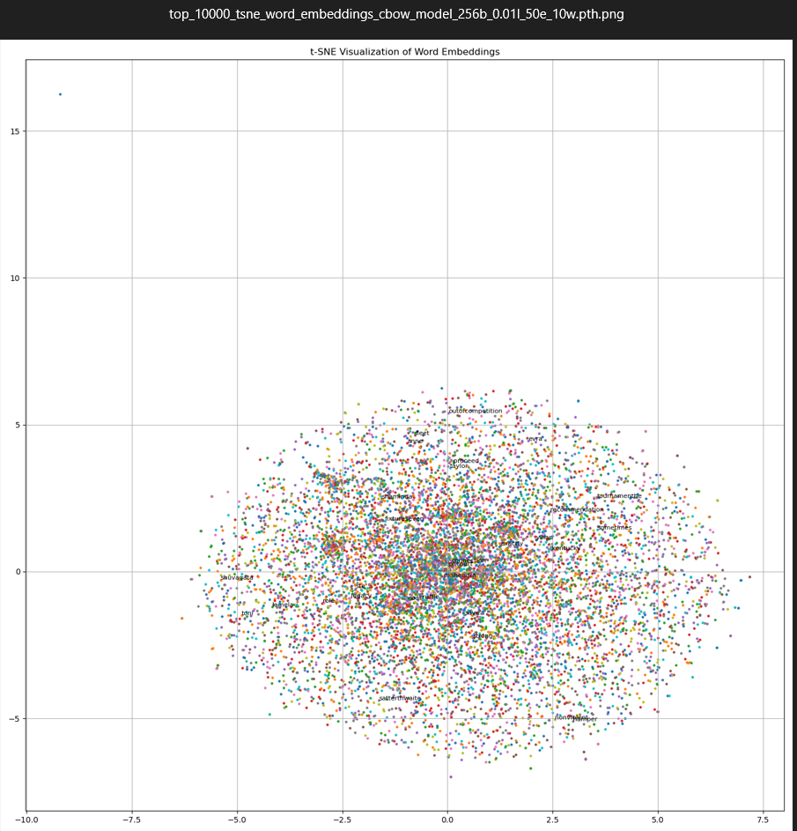

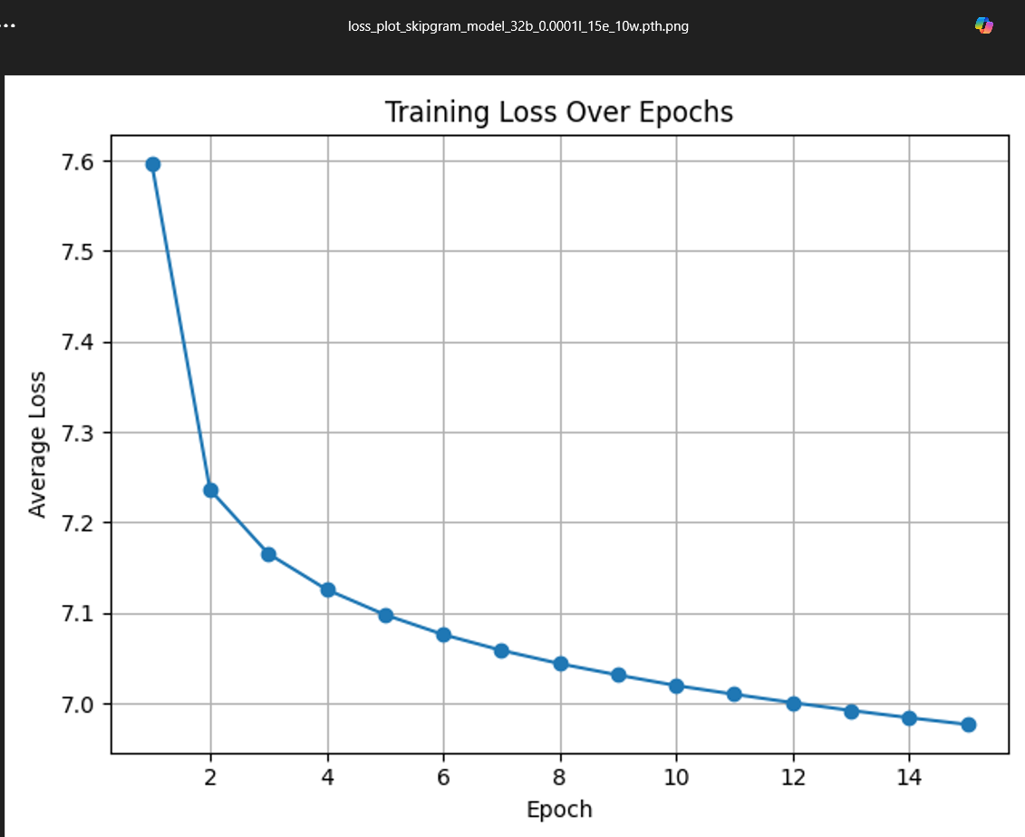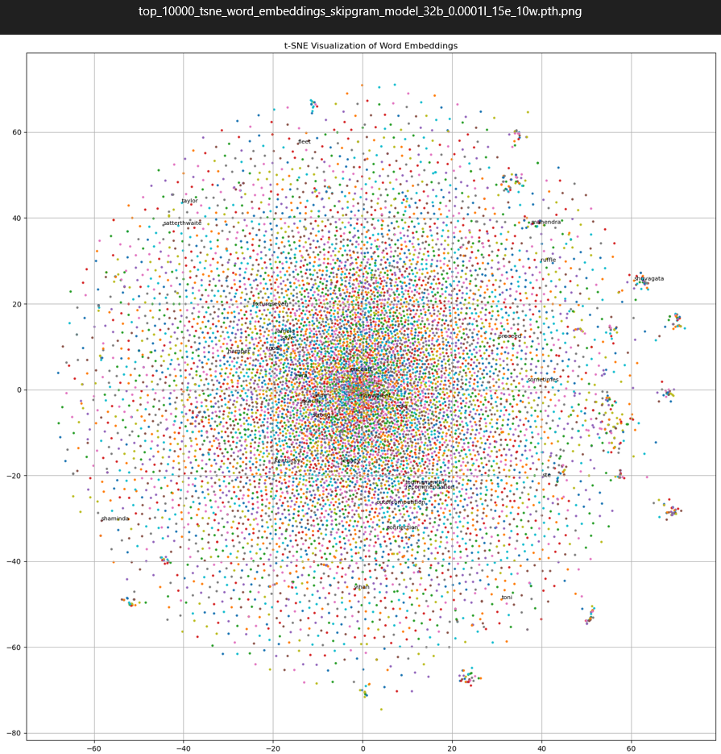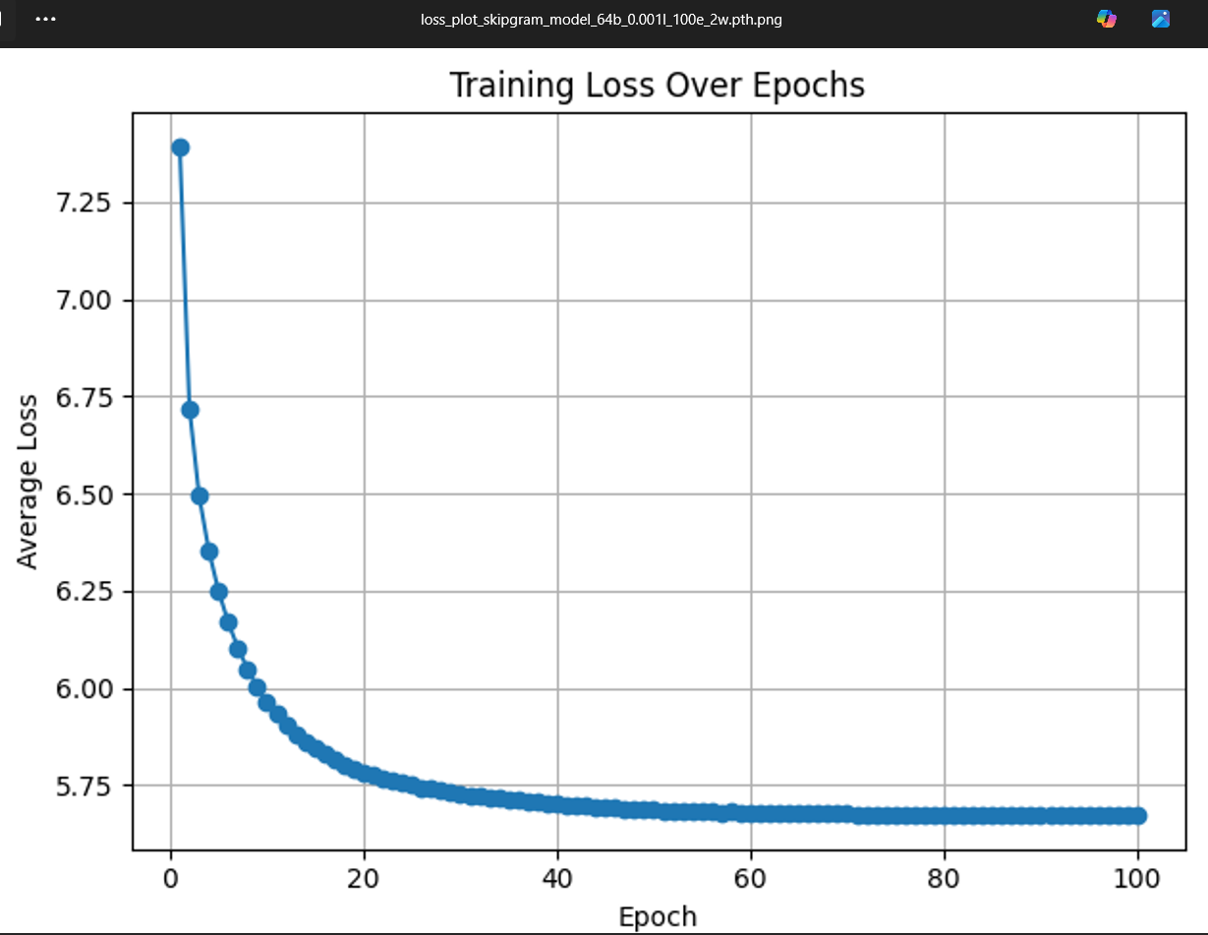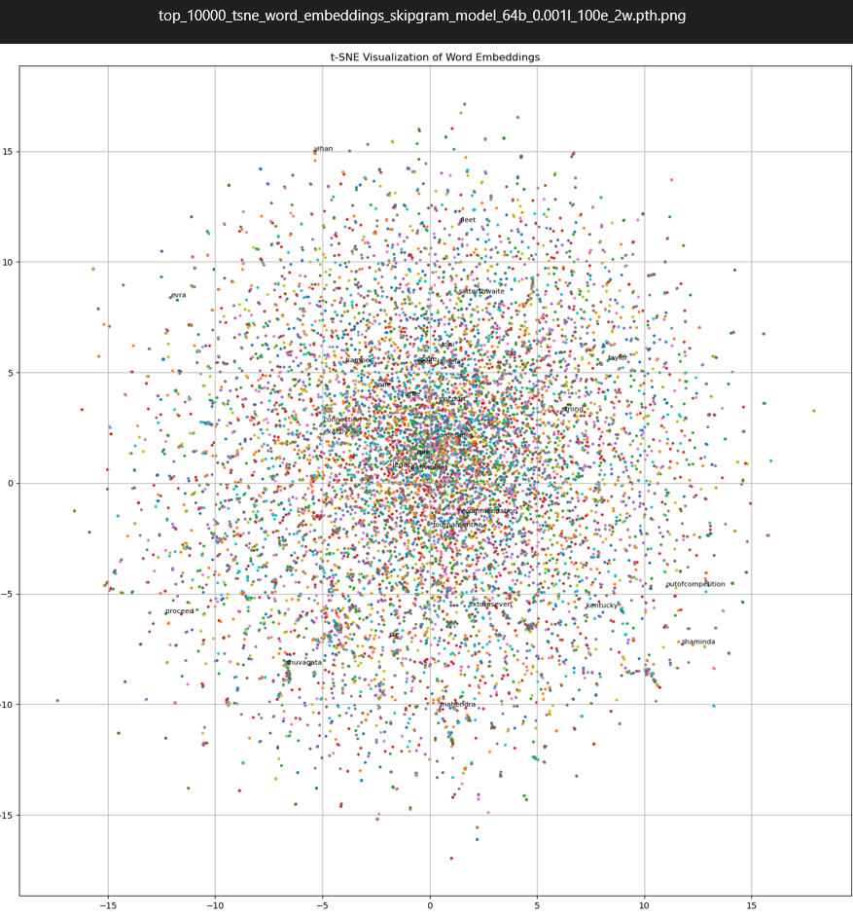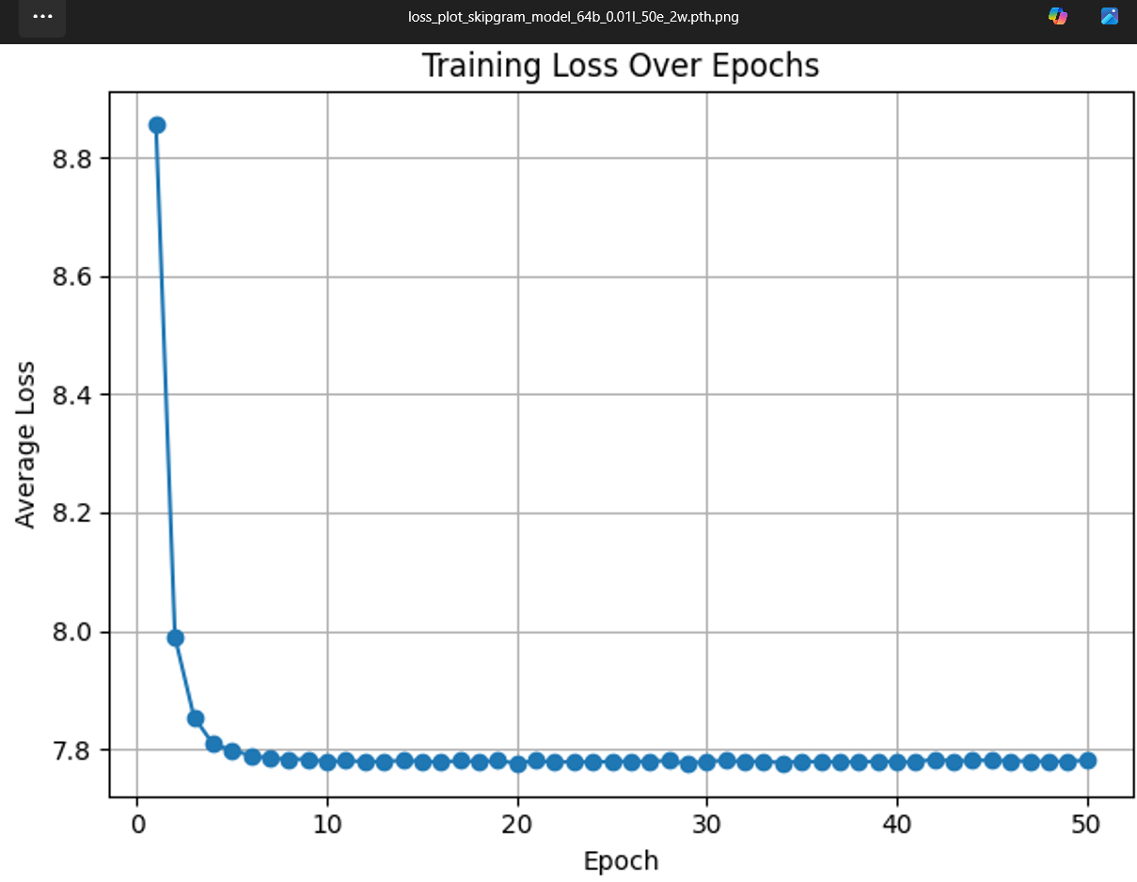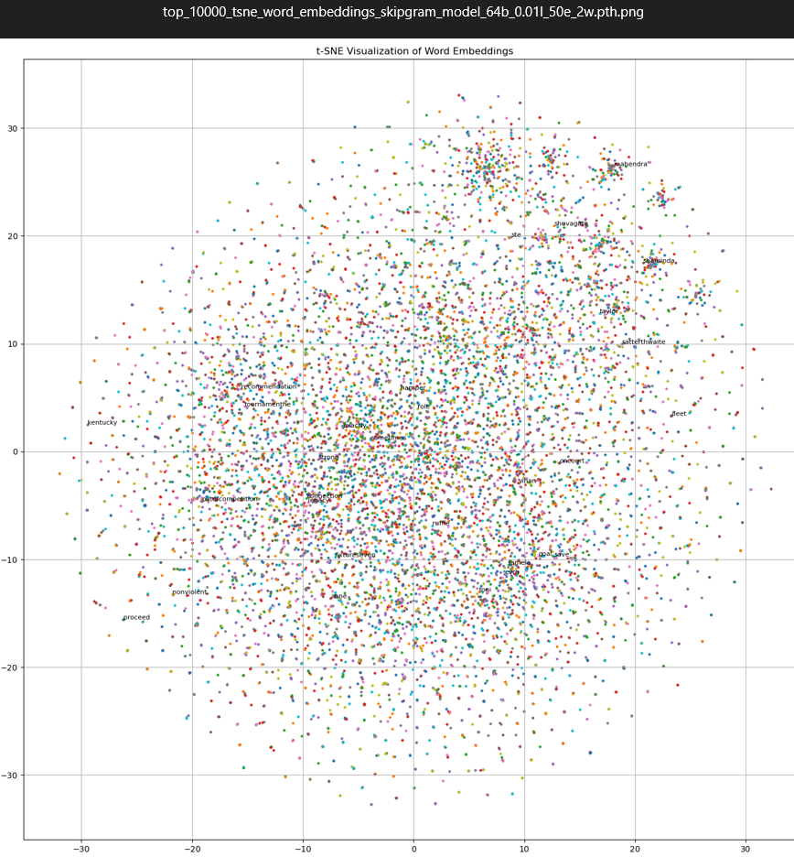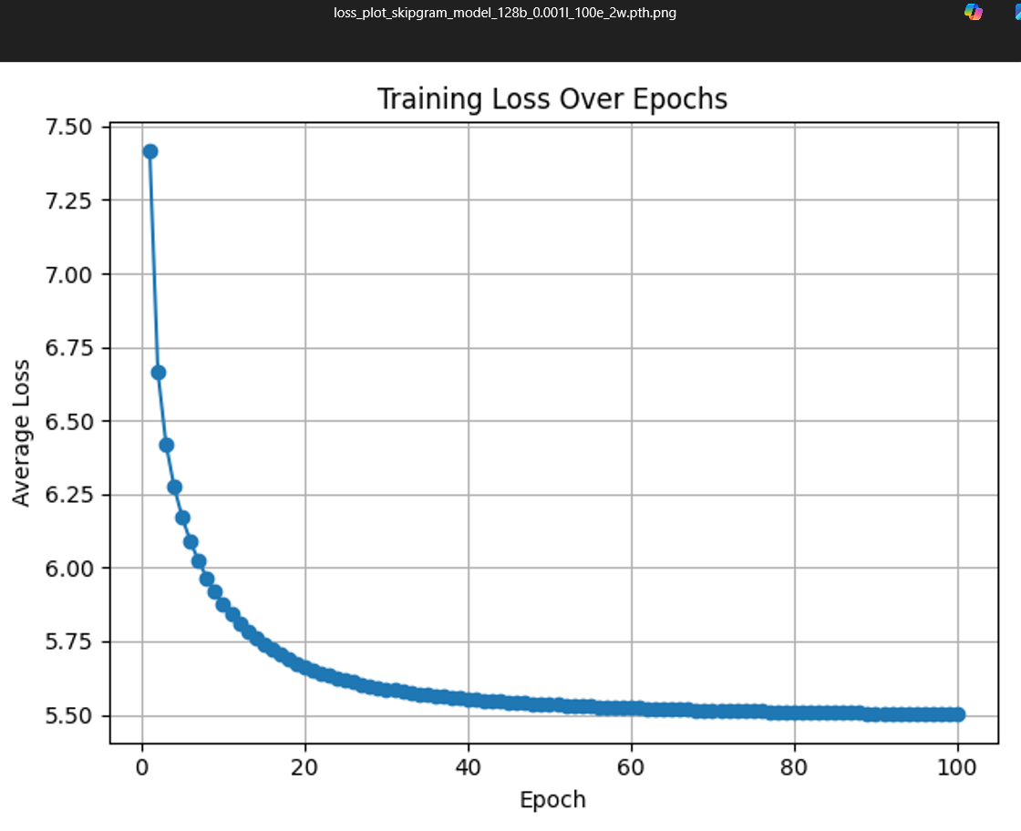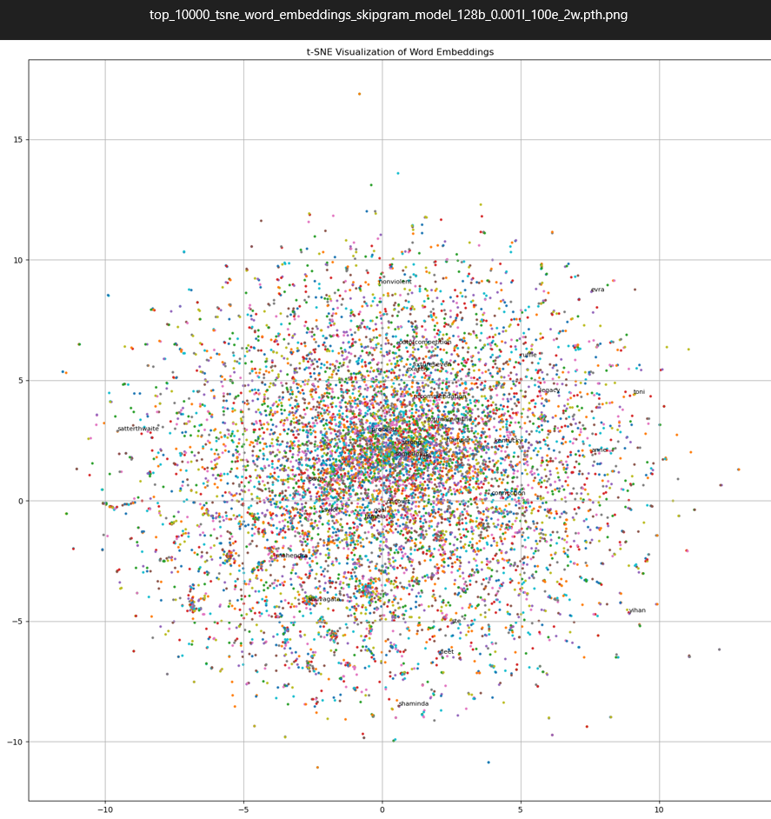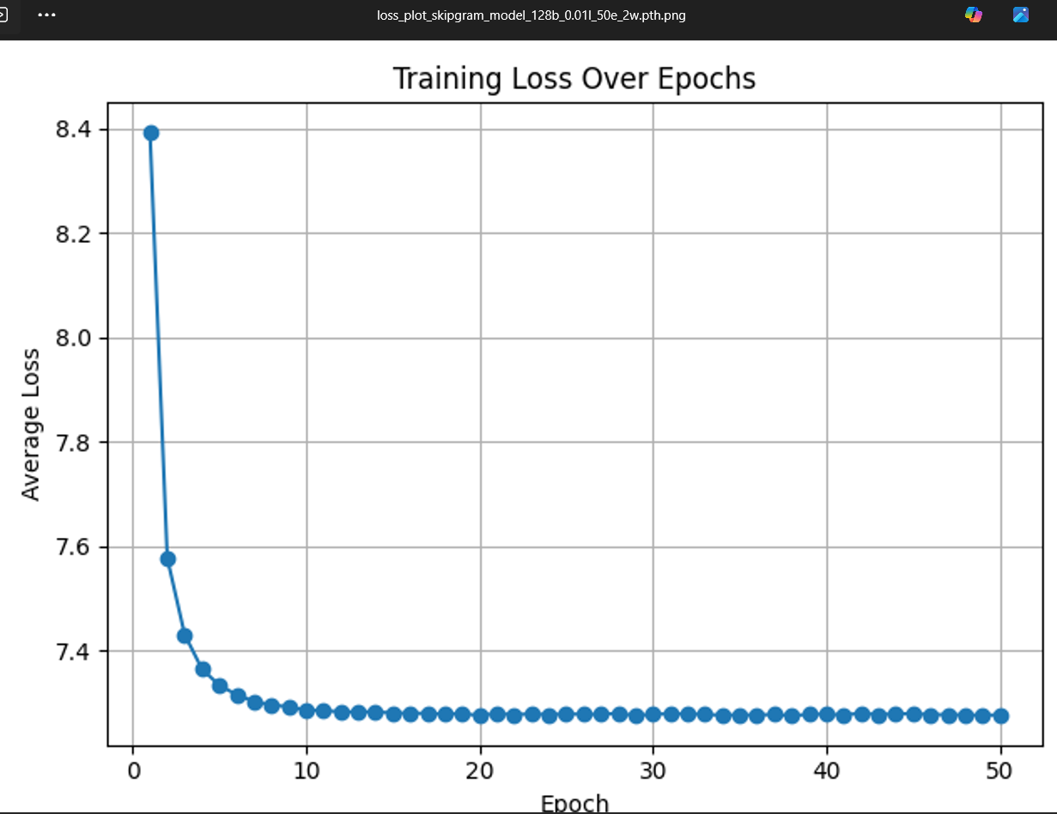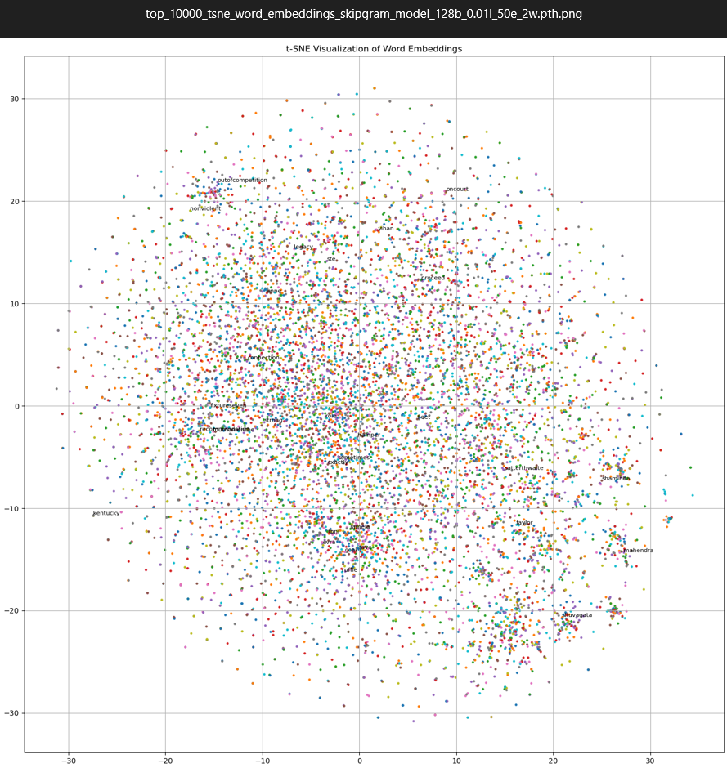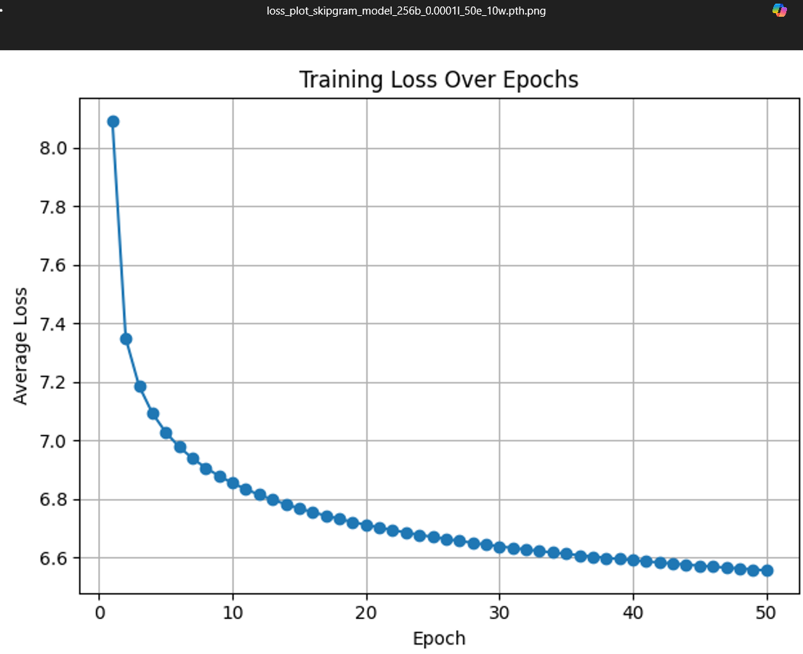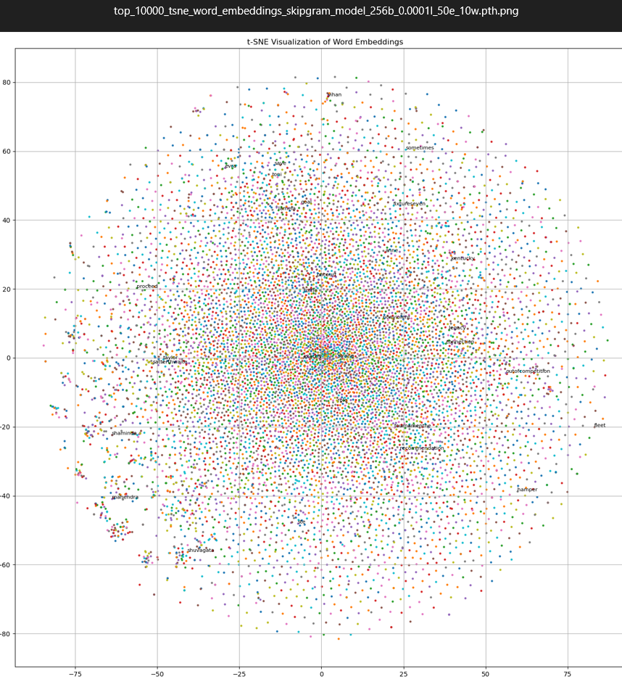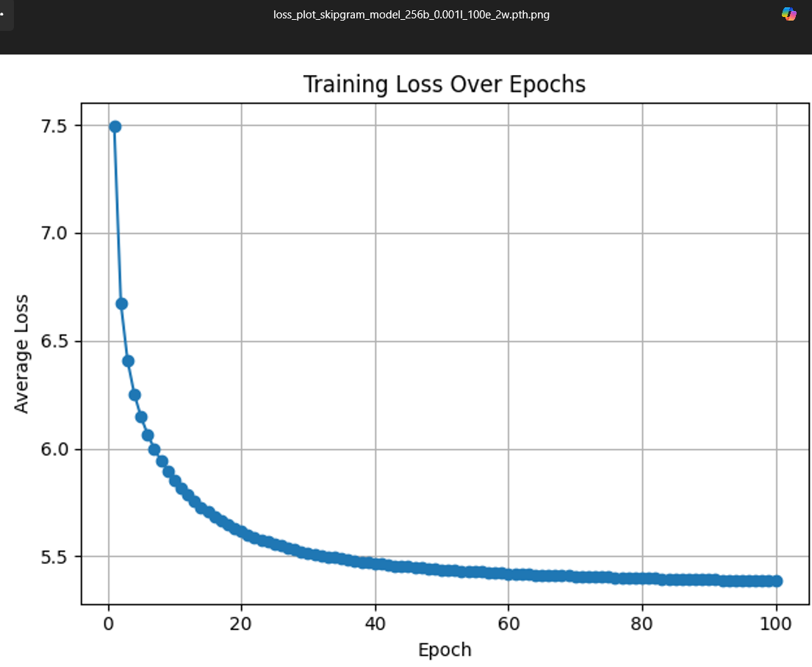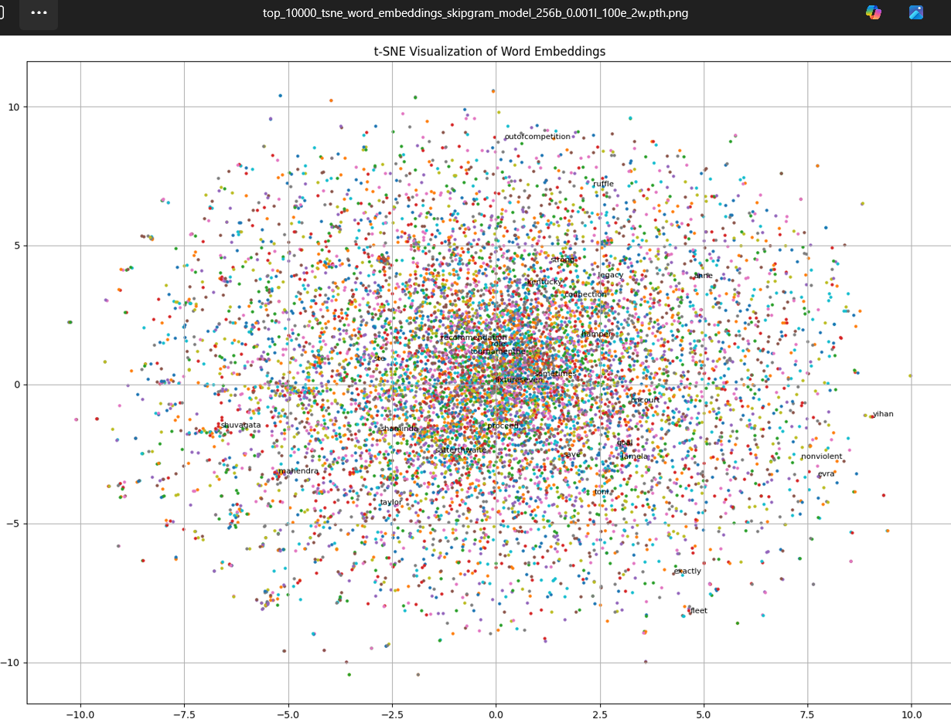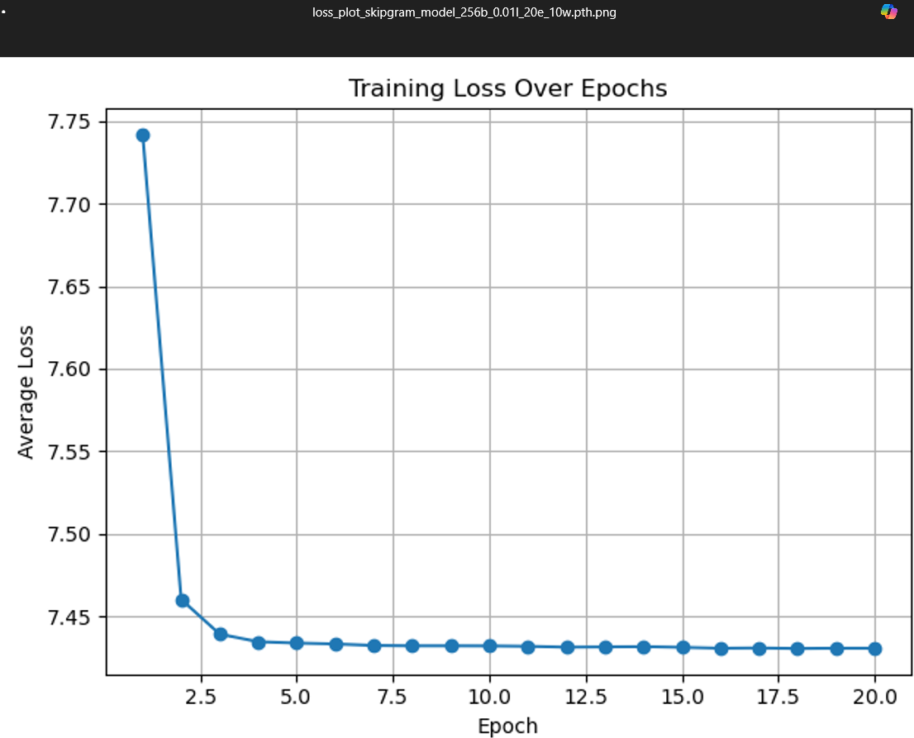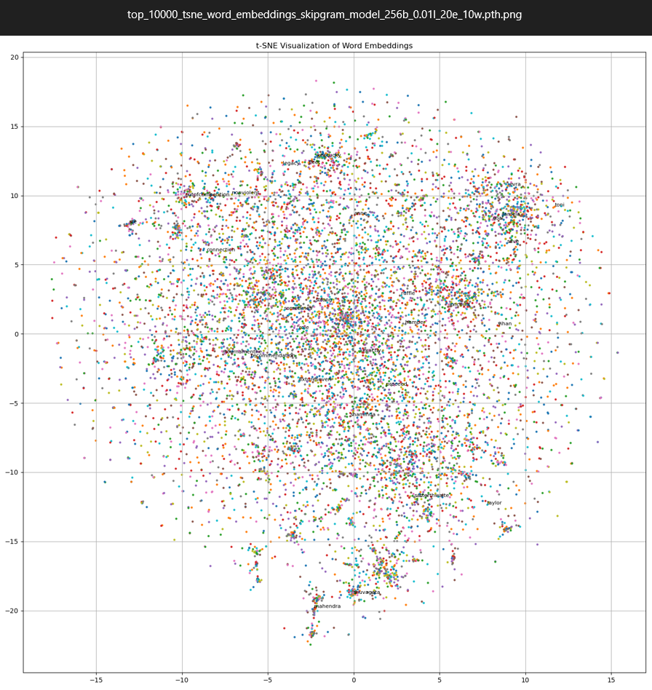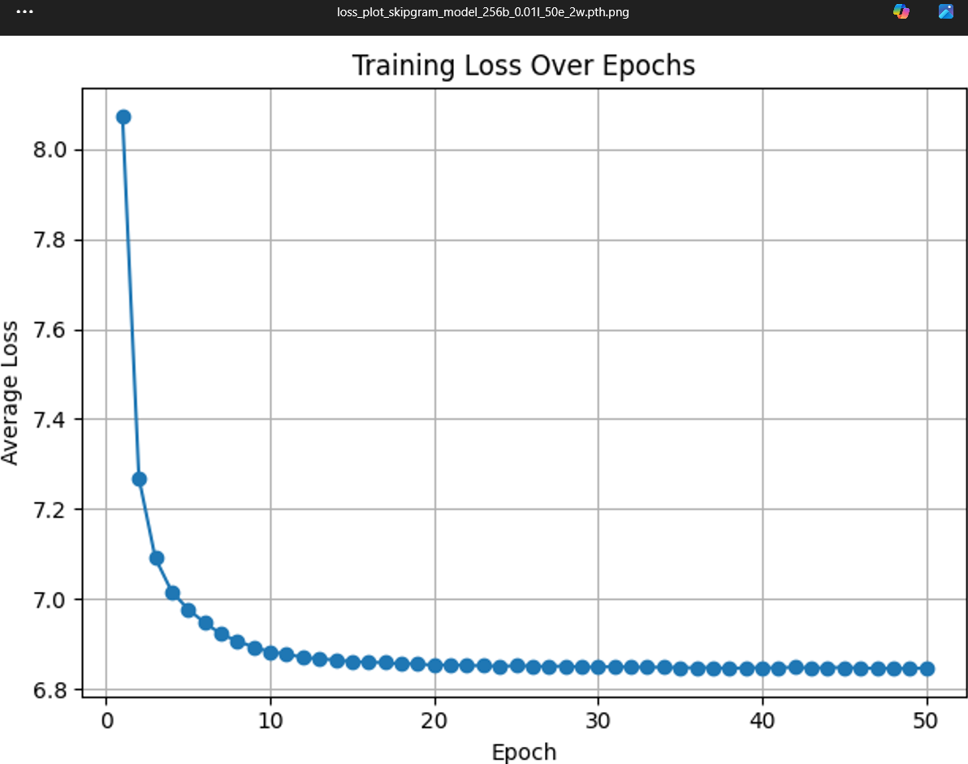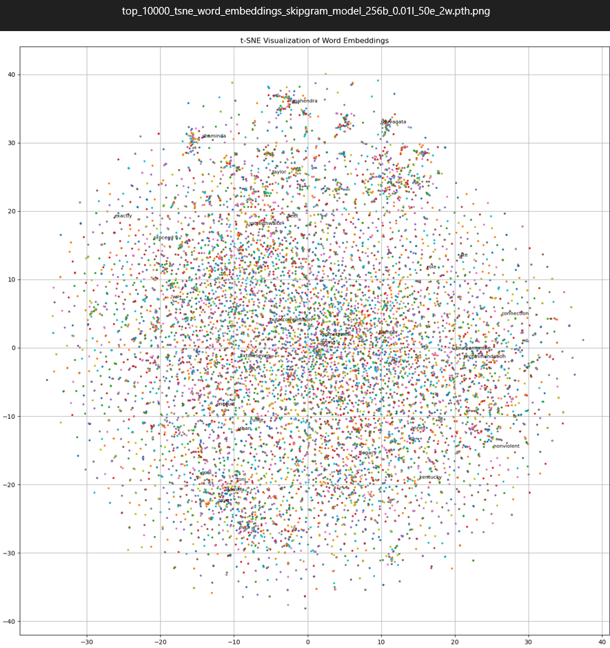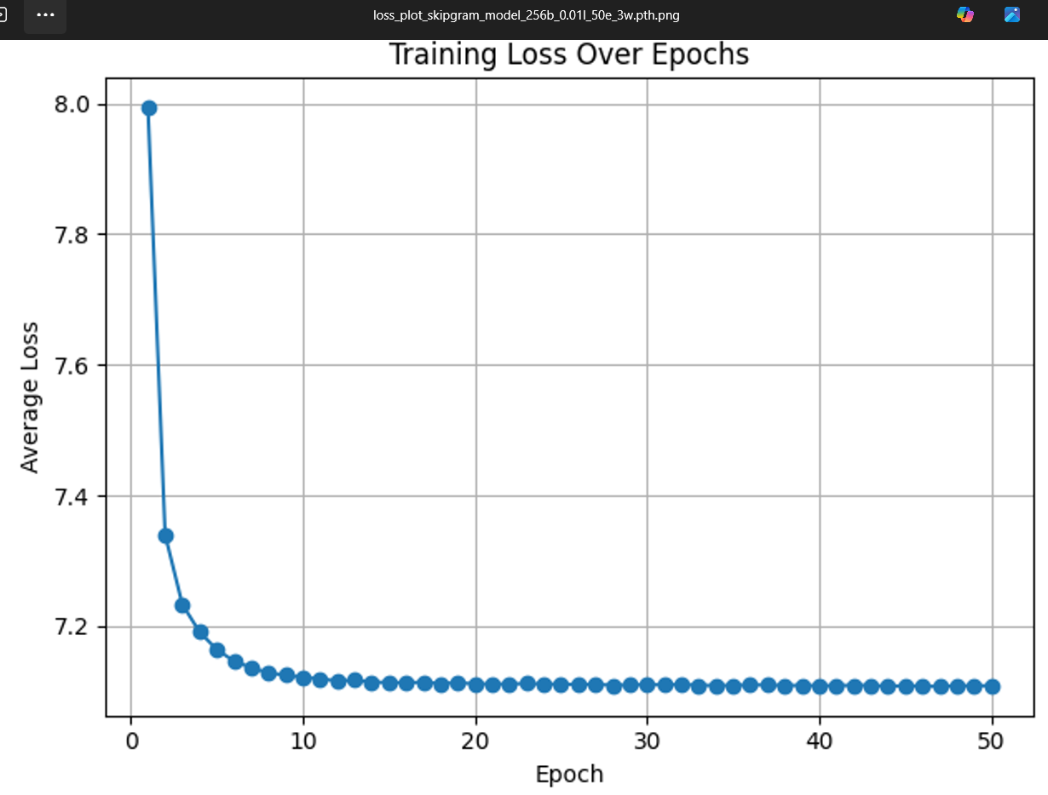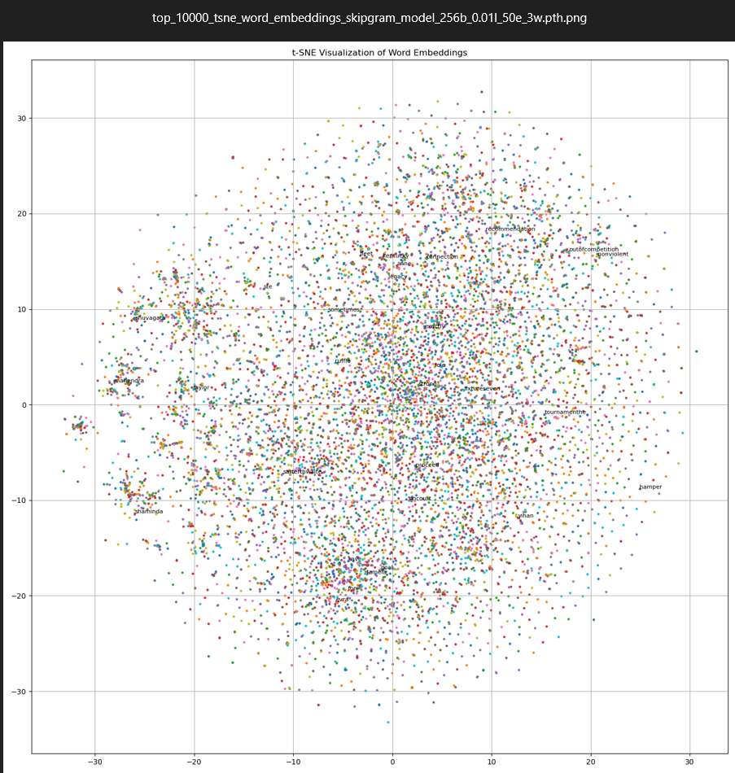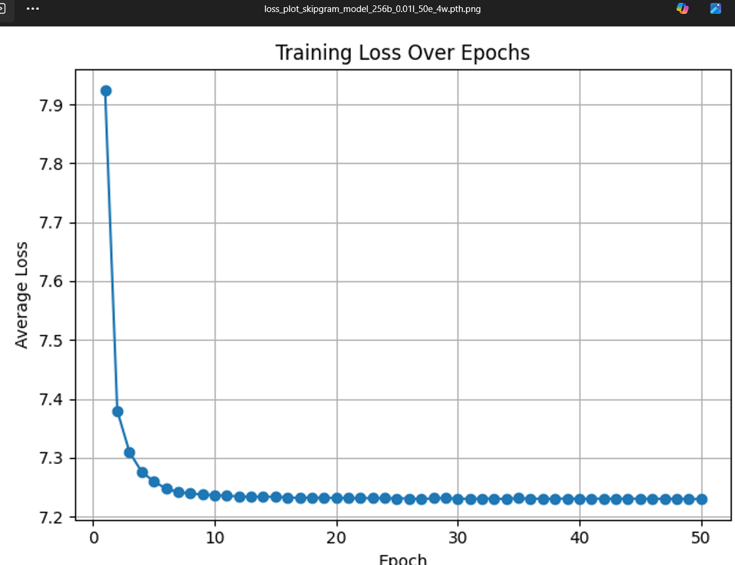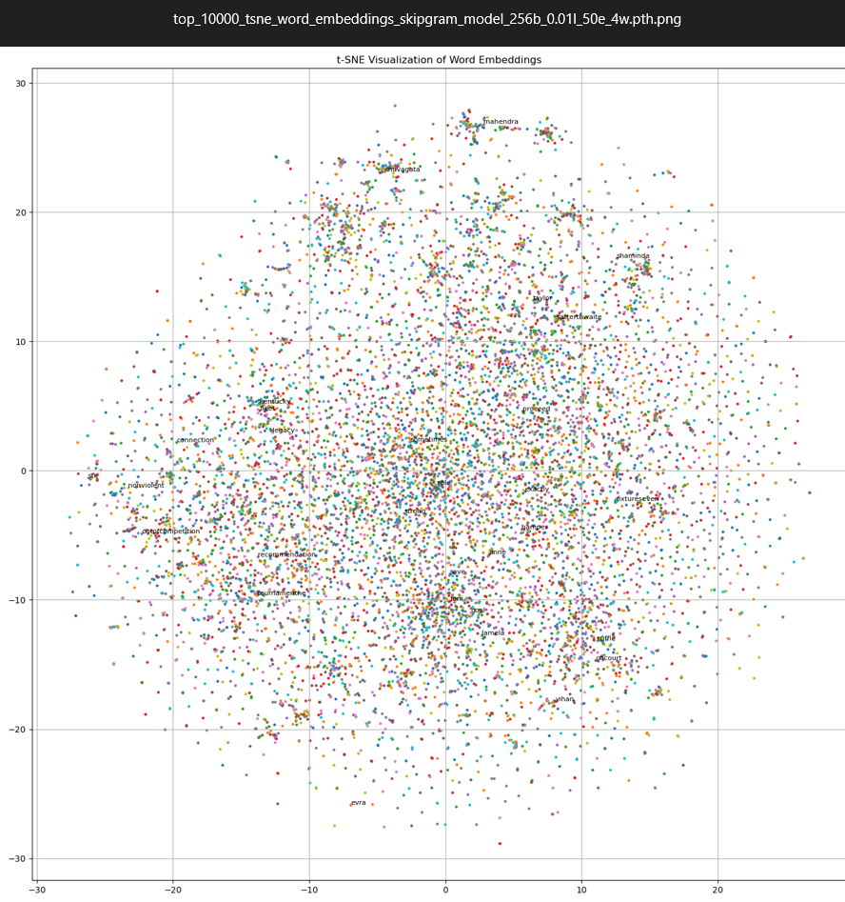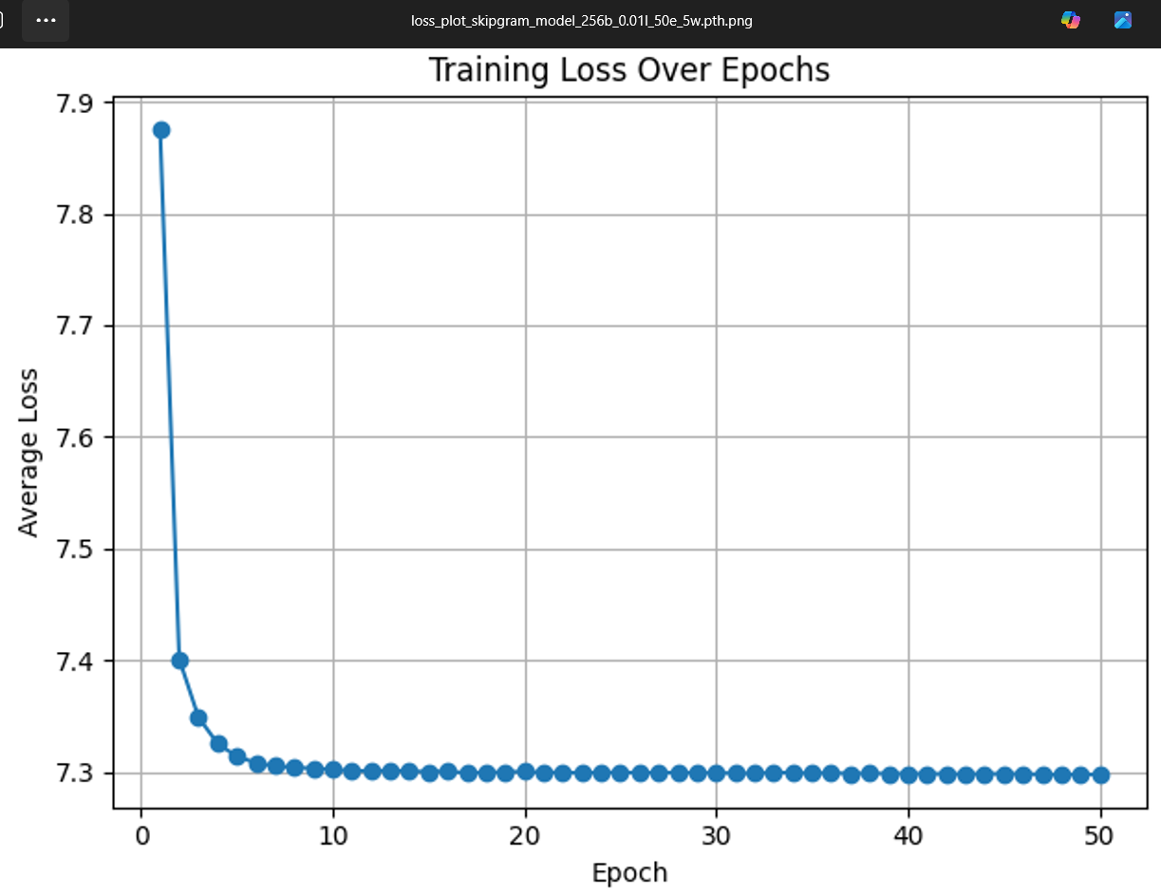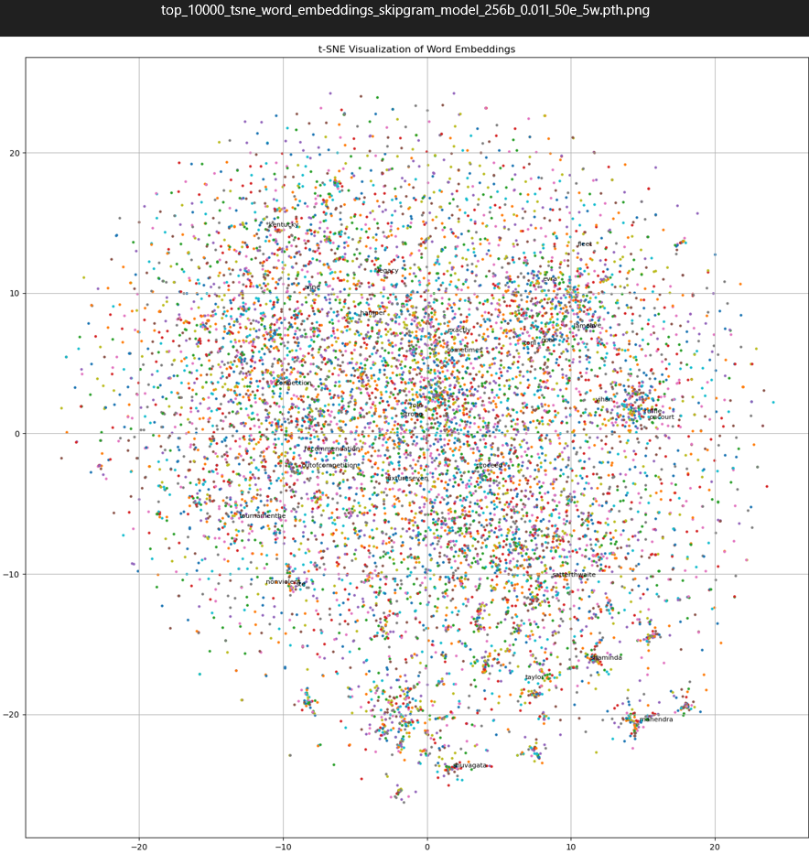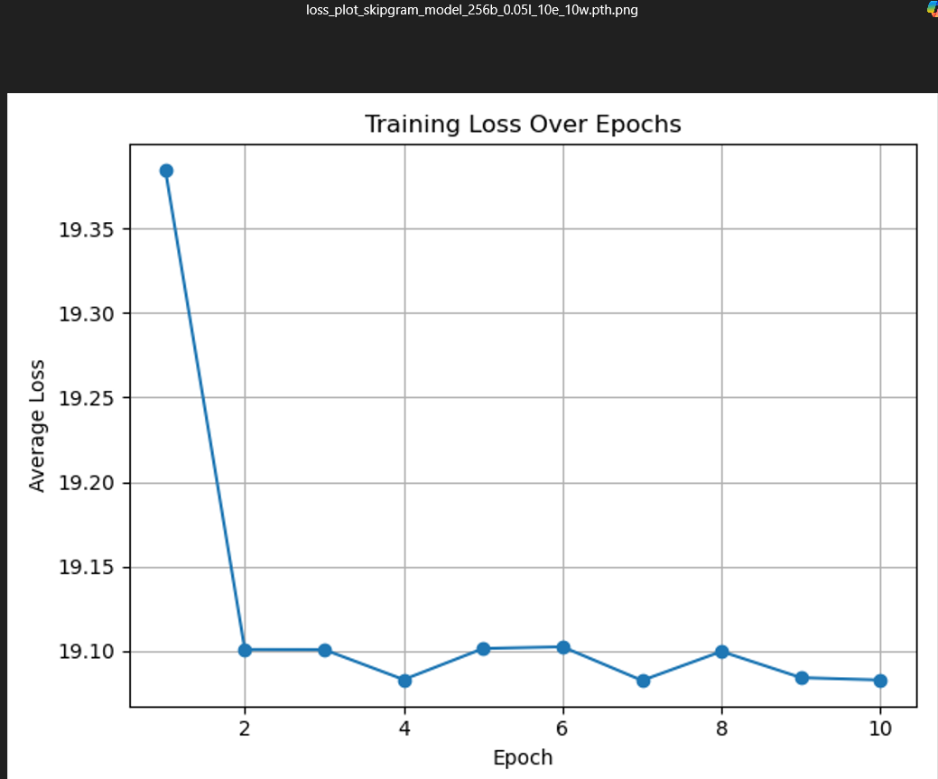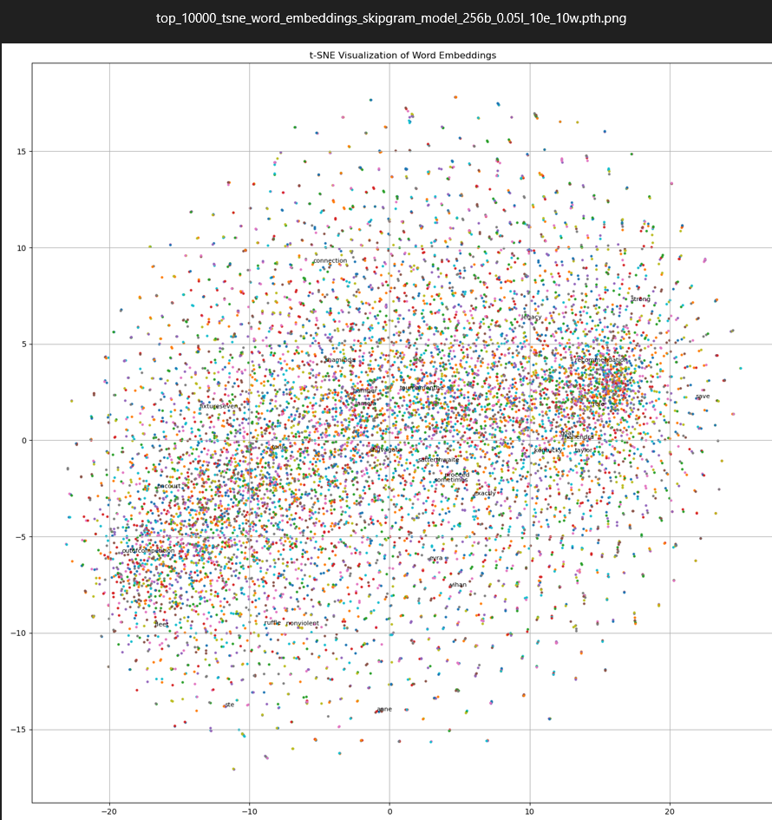

# Source Code Appendix

**1_data_pre_processing.py**

import nltk  
import spacy  
import pandas as pd  
import re  
from collections import Counter  
from nltk.corpus import stopwords  
from nltk.tokenize import word_tokenize  
from nltk.stem import WordNetLemmatizer, SnowballStemmer  
from tqdm import tqdm  
from models.consts import MAX_VOCAB_SIZE, UNK_TOKEN  
import pickle  
tqdm.pandas()  
  
# download packages for pre-processing  
nltk.download('punkt')  
nltk.download('stopwords')  
spacy.cli.download("en_core_web_sm")  
nlp = spacy.load("en_core_web_sm")  
nltk.download('punkt_tab')  
STOPWORDS = set(stopwords.words("english"))  
  
lemmatizer = WordNetLemmatizer()  
stemmer = SnowballStemmer('english')  
nlp = spacy.load("en_core_web_sm", disable=["parser", "ner"])  
  
# Task 1: Dataset Acquisition and Pre-Processing  
# data importing & initial filtering by "business"/"sports" NewsType  
news_type = "sports"  
file_path = "Data/Articles.csv"  
df = pd.read_csv(file_path, encoding='ISO-8859-1')  
df = df[df['NewsType'] == news_type]  
df = df.dropna(subset=['Article'])  
  
  
def clean_text(text):  
 # https://www.geeksforgeeks.org/machine-learning/python-efficient-text-data-cleaning/  
 # text normalisation (lower-case, etc)  
 text = text.lower()  
 # ignore non-ascii characters  
 text = text.encode('ascii', 'ignore').decode()  
 # keep only words  
 text = re.sub(r'[^a-z\s]', '', text)  
 # trim spaces  
 text = re.sub(r'\s+', ' ', text).strip()  
 return text  
  
  
df['clean_text'] = df['Article'].dropna().apply(clean_text)  
  
# tokenisation & stop-word removal  
df['tokens'] = df['clean_text'].apply(lambda x: [t for t in word_tokenize(x) if t not in STOPWORDS])  
  
  
# vocabulary limiting/filtering: for a more concise dictionary apply lemmatisation  
# https://www.kaggle.com/code/kishalmandal/all-about-stemming-and-lemmatization-cleaning lemmatisation favoured over  
# stemming because we want to learn word relationships. stemming removes such relationships and removes meaning (e.g.  
# program vs programmer -> both same stem(program), but have different meanings).  
# https://www.geeksforgeeks.org/python/python-lemmatization-with-nltk/  
  
# lemmatisation using spaCy  
def lemmatise_tokens(tokens):  
 doc = nlp(" ".join(tokens))  
 return [token.lemma_ for token in doc]  
  
  
df['lemmas'] = df['tokens'].progress_apply(lemmatise_tokens)  
  
# vocabulary creation - most common 10k words and mapped to indices  
all_lemmas = [lemma for doc in df['lemmas'] for lemma in doc]  
lemma_freq = Counter(all_lemmas)  
  
most_common = lemma_freq.most_common(MAX_VOCAB_SIZE - 1) # -1 for UNK  
vocab = {word: idx + 1 for idx, (word, _) in enumerate(most_common)} # start from 1  
vocab[UNK_TOKEN] = 0 # UNK mapped to 0  
  
  
# indexing tokens into numerical indices based on the constructed vocabulary  
def convert_to_indices(lemmas):  
 return [vocab.get(token, vocab[UNK_TOKEN]) for token in lemmas]  
  
  
df['lemmas_indices'] = df['lemmas'].apply(convert_to_indices)  
  
# print some info  
print(f"Total business articles processed: {len(df)}")  
  
# total number of tokens  
total_tokens = sum(len(lemmas) for lemmas in df['lemmas'])  
print(f"Total tokens: {total_tokens}")  
  
# vocabulary size  
print(f"Vocabulary size: {len(vocab)}")  
  
# top 20 most common words  
print("\nTop 20 most frequent lemmas:")  
for word, freq in Counter([lemma for doc in df['lemmas'] for lemma in doc]).most_common(20):  
 print(f"{word:<15} {freq}")  
  
# keep only df["lemmas"] and df["lemmas_indices"]  
df = df[['lemmas', 'lemmas_indices']]  
  
# save  
df.to_csv(f"Data/preprocessed_{news_type}_articles.csv", index=False)  
df.to_pickle(f"Data/preprocessed_{news_type}_articles.pkl")  
  
with open(f"Data/vocab_{news_type}_dict.pkl", "wb") as f:  
 pickle.dump(vocab, f)

**2_and_3_pytorch_model_training_and_optimisations.py**

import torch.nn as nn  
import random  
import pandas as pd  
import pickle  
import numpy as np  
import matplotlib.pyplot as plt  
import os  
import torch  
import torch.optim as optim  
from torch.utils.data import DataLoader  
from models.cbow import CBOWModel, CBOWDataset, generate_cbow_data  
from models.skipgram import SkipGramModel, SkipGramDataset, generate_skipgram_data  
  
# Chat GPT suggested:  
torch.set_num_threads(torch.get_num_threads()) # Use all available CPU threads  
torch.backends.mkldnn.enabled = True # Enable MKLDNN (optimized CPU kernels)  
  
if __name__ == "__main__":  
 def set_seed(seed=42):  
 random.seed(seed)  
 np.random.seed(seed)  
 torch.manual_seed(seed)  
 torch.backends.cudnn.deterministic = True  
 torch.backends.cudnn.benchmark = False  
  
 set_seed(42)  
 #https://medium.com/@RobuRishabh/learning-word-embeddings-with-cbow-and-skip-gram-b834bde18de4  
 #https://www.geeksforgeeks.org/nlp/word-embeddings-in-nlp/  
 embedding_dim = 256  
 device = torch.device("cuda" if torch.cuda.is_available() else "cpu")  
 # load dataframe  
 model_name = "cbow" #"skipgram"  
 # hyperparameters  
 batch_size = 128 #256   
 learning_rate = 0.01  
 epochs = 100 #12  
 window_size = 2 #5  
  
 category = "sports" # business  
 suffix_category = f"{category}_"  
 data_file = f"Data/preprocessed_{category}_articles.pkl"  
 vocab_file = f"Data/vocab_{category}_dict.pkl"  
  
 df = pd.read_pickle(data_file)  
  
 # load & setup  
 export_file_name = f"{model_name}_model_{batch_size}b_{learning_rate}l_{epochs}e_{window_size}w.pth"  
 export_folder_name = f"{model_name}_model_{batch_size}b_{learning_rate}l_{epochs}e_{window_size}w_files"  
 save_dir = f"models/{category}/{model_name}/{export_folder_name}"  
 os.makedirs(save_dir, exist_ok=True)  
 os.makedirs(f"{save_dir}/checkpoints", exist_ok=True)  
 with open(vocab_file, "rb") as f:  
 vocab = pickle.load(f)  
  
 # prepare data and Model  
 if model_name == "cbow":  
 model_data = generate_cbow_data(df['lemmas'].tolist(), window_size=window_size)  
 dataset = CBOWDataset(model_data, vocab)  
 model = CBOWModel(len(vocab), embedding_dim).to(device)  
 else:  
 model_data = generate_skipgram_data(df['lemmas'].tolist(), window_size=window_size)  
 dataset = SkipGramDataset(model_data, vocab)  
 model = SkipGramModel(len(vocab), embedding_dim).to(device)  
  
 # mini batches  
 dataloader = DataLoader(dataset, batch_size=batch_size, shuffle=True, num_workers=4)  
  
 # loss, and optimizer  
 criterion = nn.CrossEntropyLoss()  
 optimizer = optim.Adam(model.parameters(), lr=learning_rate)  
 loss_history = []  
  
 # training loop  
 for epoch in range(epochs):  
 total_loss = 0  
 model.train()  
  
 # adapted from https://github.com/FraLotito/pytorch-continuous-bag-of-words/blob/master/cbow.py  
 # adapted training loop from both https://leshem-ido.medium.com/skip-gram-word2vec-algorithm-explained-85cd67a45ffa and https://github.com/FraLotito/pytorch-continuous-bag-of-words/blob/master/cbow.py  
 # also optimised by ChatGPT  
 for context_idxs, target_idx in dataloader:  
 context_idxs = context_idxs.to(device)  
 target_idx = target_idx.to(device)  
 optimizer.zero_grad()  
 # forward  
 output = model(context_idxs) # output shape: (batch_size, vocab_size)  
 loss = criterion(output, target_idx)  
 loss.backward()  
 optimizer.step()  
  
 total_loss += loss.item()  
  
 avg_loss = total_loss / len(dataloader)  
 loss_history.append(avg_loss) # log the average loss  
 print(f"Epoch {epoch + 1}/{epochs}, Loss: {avg_loss:.4f}")  
 # save the trained model  
 if (epoch + 1) % 10 == 0:  
 os.makedirs(f"{save_dir}/checkpoints/checkpoint_{epoch}e", exist_ok=True),  
 torch.save(model.state_dict(), f"{save_dir}/checkpoints/checkpoint_{epoch}e/checkpoint_{epoch}e_{export_file_name}")  
 loss_df = pd.DataFrame({'epoch': range(1, epoch + 2), 'loss': loss_history})  
 loss_df.to_csv(f"{save_dir}/checkpoints/checkpoint_{epoch}e/training_loss_log_checkpoint_{epoch}e_{export_file_name}.csv", index=False)  
  
 torch.save(model.state_dict(), f"{save_dir}/{export_file_name}")  
 loss_df = pd.DataFrame({'epoch': range(1, epochs + 1), 'loss': loss_history})  
 loss_df.to_csv(f"{save_dir}/training_loss_log_{export_file_name}.csv", index=False)  
  
 plt.plot(range(1, epochs + 1), loss_history, marker='o')  
 plt.title("Training Loss Over Epochs")  
 plt.xlabel("Epoch")  
 plt.ylabel("Average Loss")  
 plt.grid(True)  
 plt.tight_layout()  
 plt.savefig(f"{save_dir}/loss_plot_{export_file_name}.png")  
 plt.show()  
  
 print(f"Model saved to {save_dir}")

**4_tSNE_visualisation_and_analysis.py**

import torch  
import random  
import pickle  
from models.consts import UNK_TOKEN  
from models.cbow import CBOWModel  
from models.skipgram import SkipGramModel  
from sklearn.manifold import TSNE  
import numpy as np  
import pandas as pd  
import matplotlib.pyplot as plt  
import os  
  
# Chat GPT suggested:  
torch.set_num_threads(torch.get_num_threads())  
torch.backends.mkldnn.enabled = True  
  
  
def set_seed(seed=42):  
 random.seed(seed)  
 np.random.seed(seed)  
 torch.manual_seed(seed)  
 torch.backends.cudnn.deterministic = True  
 torch.backends.cudnn.benchmark = False  
  
  
set_seed(42)  
device = torch.device("cpu")  
  
# set params  
model_name = "cbow" # "skipgram"  
batch_size = "128" #256  
lr = "0.01"  
epochs = "100" #"12"  
window = "2" # "5"  
filepath = f"models/sports/{model_name}/{model_name}_model_{batch_size}b_{lr}l_{epochs}e_{window}w_files/"  
filename = f"{model_name}_model_{batch_size}b_{lr}l_{epochs}e_{window}w.pth"  
  
embedding_dim = 256  
  
convergence_visual_path = f"{filepath}loss_plot_{filename}.png"  
if os.path.exists(convergence_visual_path) == False:  
 df = pd.read_csv(f"{filepath}training_loss_log_{filename}.csv")  
 loss = df["loss"].astype(float).tolist()  
 plt.plot(range(1, int(epochs) + 1), loss, marker='o')  
 plt.title("Training Loss Over Epochs")  
 plt.xlabel("Epoch")  
 plt.ylabel("Average Loss")  
 plt.grid(True)  
 plt.tight_layout()  
 plt.savefig(convergence_visual_path)  
 plt.show()  
  
 print(f"Model saved to {convergence_visual_path}")  
  
# load data  
with open("Data/vocab_sports_dict.pkl", "rb") as f:  
 vocab = pickle.load(f)  
  
if model_name == "cbow":  
 model = CBOWModel(len(vocab), embedding_dim).to(device)  
else:  
 model = SkipGramModel(len(vocab), embedding_dim).to(device)  
  
# load saved state dict  
model.load_state_dict(torch.load(filepath + filename, map_location=device))  
print(model.eval())  
  
# get embedding weights: shape (vocab_size, embedding_dim)  
embeddings = model.embeddings.weight.data.cpu().numpy()  
  
# dimensionality reduction:  
# use t-SNE to reduce the high-dimensional embeddings to 2D space. https://scikit-learn.org/stable/modules/generated/sklearn.manifold.TSNE.html  
tsne = TSNE(n_components=2, random_state=42, perplexity=30, max_iter=1000)  
embeddings_2d = tsne.fit_transform(embeddings)  
  
# Invert vocab dictionary to get word from index  
idx_to_word = {idx: word for word, idx in vocab.items()}  
plt.figure(figsize=(14, 14))  
  
# Plot entire vocab, but plot only top 30 words  
n = 30  
N = 10000  
for i in range(N):  
 x, y = embeddings_2d[i, 0], embeddings_2d[i, 1]  
 word = idx_to_word.get(i, UNK_TOKEN)  
 plt.scatter(x, y, s=5)  
  
# Randomly select n unique indices to label  
label_indices = random.sample(range(N), n)  
  
for i in label_indices:  
 x, y = embeddings_2d[i, 0], embeddings_2d[i, 1]  
 word = idx_to_word.get(i, UNK_TOKEN)  
 plt.text(x + 0.002, y + 0.002, word, fontsize=8)  
  
# plt.xlim(-8, 8)  
# plt.ylim(-8, 8)  
  
plt.title("t-SNE Visualization of Word Embeddings")  
plt.grid(True)  
plt.tight_layout()  
plt.savefig(f"{filepath}top_{N}_tsne_word_embeddings_{filename}.png")  
  
# define groups for better analysis  
categories = {  
 'Gender': ["man", "woman", "boy", "girl", "male", "female", "men", "women", "womens"],  
 'Royalty': ["king", "queen", "man", "woman", "prince", "princess"],  
 'Business': ["businessman", "man", "business", "businessmenin"],  
 'Sports': ["foot", "ball", "football", "soccer", "american", "cricket", "india", "basketball", "america", "states",  
 "olympics", "major", "tournament", "handball"],  
 'Country': ["america", "american", "british", "english", "england", "united", "states", "ozil", "mueller",  
 "germany", "germans", "turkey", "bonucci", "armbonucci", "italy"],  
 'Colors': ["yellow", "gold", "red", "green", "blue", "angry"],  
 'Position': ["silver", "second", "gold", "first", "third", "bronze", "win", "lose"]  
}  
  
# plot of filtered word embeddings for analysis  
for key, word_list in categories.items():  
 words_subset = [word for word in word_list if word in vocab]  
 indices = [vocab[word] for word in words_subset]  
 coords = embeddings_2d[indices]  
 plt.figure(figsize=(10, 8))  
 for i, word in enumerate(words_subset):  
 x, y = coords[i]  
 plt.scatter(x, y, color='blue')  
 plt.text(x + 0.02, y + 0.02, word, fontsize=10)  
  
 plt.title("t-SNE Plot of Selected Word Embeddings")  
 plt.grid(True)  
 plt.tight_layout()  
 plt.savefig(f"{filepath}{key}_subset_words_tsne_{filename}.png")  
  
# save embeddings to csv  
data = []  
for i in range(len(embeddings_2d)):  
 word = idx_to_word.get(i, UNK_TOKEN)  
 x, y = embeddings_2d[i]  
 data.append((word, x, y))  
  
df = pd.DataFrame(data, columns=['word', 'x', 'y'])  
csv_path = f"{filepath}tsne_embeddings_{filename}.csv"  
df.to_csv(csv_path, index=False)

**models/word_embedding.py**

import torch.nn as nn  
  
class WordEmbeddingModel(nn.Module):  
 def __init__(self, vocab_size, embedding_dim):  
 super(WordEmbeddingModel, self).__init__()  
 self.embeddings = nn.Embedding(vocab_size, embedding_dim)  
  
 def get_embedding(self, input_ids):  
 return self.embeddings(input_ids)

**skipgram.py**

import torch  
import torch.nn as nn  
from torch.utils.data import Dataset  
  
from models.consts import UNK_TOKEN  
from .word_embedding import WordEmbeddingModel  
import torch.nn.functional as F  
  
# Chat GPT suggested:  
torch.set_num_threads(torch.get_num_threads())  
torch.backends.mkldnn.enabled = True  
  
# Boilerplate code from ChatGPT, but later adapted to incorporate code from:  
# https://leshem-ido.medium.com/skip-gram-word2vec-algorithm-explained-85cd67a45ffa  
class SkipGramModel(WordEmbeddingModel):  
 def __init__(self, vocab_size, embedding_dim):  
 super(SkipGramModel, self).__init__(vocab_size, embedding_dim)  
 self.linear = nn.Linear(embedding_dim, vocab_size)  
  
 def forward(self, center_idxs):  
 # center_idxs: (batch_size)  
 # shape: (batch_size, emb_dim)  
 embeds = self.embeddings(center_idxs)  
 out = self.linear(embeds)  
 log_probs = F.log_softmax(out, dim=1)  
 return log_probs  
  
# Boilerplate code from ChatGPT, but later adapted to incorporate code from  
# https://leshem-ido.medium.com/skip-gram-word2vec-algorithm-explained-85cd67a45ffa  
class SkipGramDataset(Dataset):  
 def __init__(self, data, vocab):  
 self.data = data  
 self.vocab = vocab  
  
 def __len__(self):  
 return len(self.data)  
  
 def __getitem__(self, idx):  
 center, context = self.data[idx]  
 center_idx = torch.tensor(self.vocab.get(center, self.vocab[UNK_TOKEN]), dtype=torch.long)  
 context_idx = torch.tensor(self.vocab.get(context, self.vocab[UNK_TOKEN]), dtype=torch.long)  
 return center_idx, context_idx  
  
#https://leshem-ido.medium.com/skip-gram-word2vec-algorithm-explained-85cd67a45ffa  
def generate_skipgram_data(tokens_list, window_size=2):  
 data = []  
 for tokens in tokens_list:  
 for i in range(len(tokens)):  
 center = tokens[i]  
 for j in range(max(0, i - window_size), min(len(tokens), i + window_size + 1)):  
 if j != i:  
 data.append((center, tokens[j]))  
 return data

**consts.py**

MAX_VOCAB_SIZE = 10000  
UNK_TOKEN = "<UNK>"

**cbow.py**

import torch  
import torch.nn as nn  
from .word_embedding import WordEmbeddingModel  
from torch.utils.data import Dataset  
from .consts import UNK_TOKEN  
import torch.nn.functional as F  
  
# Chat GPT suggested:  
torch.set_num_threads(torch.get_num_threads())  
torch.backends.mkldnn.enabled = True # For optimized CPU kernels  
  
# Boilerplate code from ChatGPT, but later adapted to incorporate code from  
# https://github.com/FraLotito/pytorch-continuous-bag-of-words/blob/master/cbow.py  
class CBOWModel(WordEmbeddingModel):  
 def __init__(self, vocab_size, embedding_dim):  
 super(CBOWModel, self).__init__(vocab_size, embedding_dim)  
 self.linear = nn.Linear(embedding_dim, vocab_size)  
  
 def forward(self, context_idxs):  
 # context_idxs: (batch_size, context_window*2)  
 # shape: (batch_size, context_size, emb_dim)  
 embeds = self.embeddings(context_idxs)  
 # average over context  
 context_embed = embeds.mean(dim=1)  
 out = self.linear(context_embed)  
 log_probs = F.log_softmax(out, dim=1)  
 return log_probs  
  
  
# Dataset class for CBOW  
# Boilerplate code from ChatGPT, but later adapted to incorporate code from:  
# https://github.com/FraLotito/pytorch-continuous-bag-of-words/blob/master/cbow.py  
class CBOWDataset(Dataset):  
 def __init__(self, data, vocab):  
 self.data = data  
 self.vocab = vocab  
  
 def __len__(self):  
 return len(self.data)  
  
 def __getitem__(self, idx):  
 context, target = self.data[idx]  
 context_idxs = torch.tensor([self.vocab.get(w, self.vocab[UNK_TOKEN]) for w in context], dtype=torch.long)  
 target_idx = torch.tensor(self.vocab.get(target, self.vocab[UNK_TOKEN]), dtype=torch.long)  
 return context_idxs, target_idx  
  
  
# altered from https://github.com/FraLotito/pytorch-continuous-bag-of-words/blob/master/cbow.py  
def generate_cbow_data(tokens_list, window_size=2):  
 data = []  
 for tokens in tokens_list:  
 for i in range(window_size, len(tokens) - window_size):  
 context = tokens[i - window_size:i] + tokens[i + 1:i + window_size + 1]  
 target = tokens[i]  
 data.append((context, target))  
 return data

# References

[1] J. Abela, ‘JA117 NLP Transformers & Large Language Models (LLMs) Part 1 – Introduction and Concepts’, University Of Malta, 2025.

[2] J. Abela, ‘JA117 NLP Transformers & Large Language Models (LLMs) Part 2 – Preliminaries’, University Of Malta, 2025.

[3] J. Abela, ‘JA117 NLP Transformers & Large Language Models (LLMs) Part 3 – Word Embeddings’, University Of Malta, 2025.

[4] G. C. J. D. Tomas Mikolov Kai Chen, “Efficient Estimation of Word Representations in Vector Space.” 2013. [Online]. Available: https://arxiv.org/abs/1301.3781

[5] J. Pennington, R. Socher, and C. D. Manning, “Glove: Global vectors for word representation,” Proceedings of the 2014 conference on empirical methods in natural language processing (EMNLP), pp. 1532–1543, 2014

[6] A. Joulin, E. Grave, P. Bojanowski, M. Douze, H. Jégou, and T. Mikolov, “FastText.zip: Compressing text classification models.” 2016. [Online]. Available: https://arxiv.org/abs/1612.03651

[7] P. Bojanowski, E. Grave, A. Joulin, and T. Mikolov, “Enriching Word Vectors with Subword Information.” 2017. [Online]. Available: https://arxiv.org/abs/1607.04606

[8] J. Devlin, M. W. Chang, K. Lee, and K. Toutanova, “BERT: Pre-training of Deep Bidirectional Transformers for Language Understanding.” 2019. [Online]. Available: https://arxiv.org/abs/1810.04805

[9] M. E. Peters et al., “Deep contextualized word representations.” 2018. [Online]. Available: https://arxiv.org/abs/1802.05365

[10] A. Vaswani et al., “Attention is All you Need,” in Advances in Neural Information Processing Systems, I. Guyon, U. von Luxburg, S. Bengio, H. Wallach, R. Fergus, S. Vishwanathan, and R. Garnett, Eds., Curran Associates, Inc., 2017. [Online]. Available: https://proceedings.neurips.cc/paper_files/paper/2017/file/3f5ee243547dee91fbd053c1c4a845aa-Paper.pdf

[11] F. Almeida and G. Xexéo, “Word Embeddings: A Survey.” 2023. [Online]. Available: https://arxiv.org/abs/1901.09069

# ChatGPT usage

Search terms for the literature review were suggested

ChatGPT also aided in the highlighting of results from Pennington et al. [5], suggesting what to focus on in the literature review.

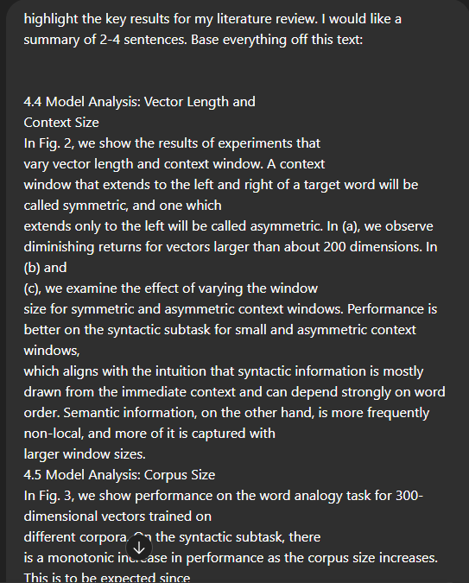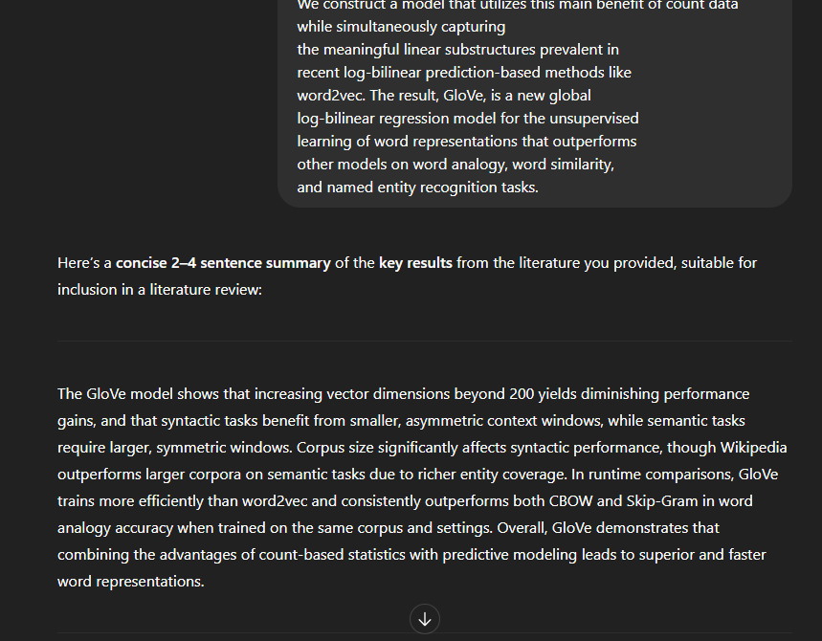

ChatGPT provided a starting point in establishing a boilerplate model to train. Refinements were done by referring to other sources like:

* [pytorch-continuous-bag-of-words/cbow.py at master · FraLotito/pytorch-continuous-bag-of-words · GitHub](https://github.com/FraLotito/pytorch-continuous-bag-of-words/blob/master/cbow.py)
* [Skip-Gram Word2Vec Algorithm Explained | by Ido Leshem | Medium](https://leshem-ido.medium.com/skip-gram-word2vec-algorithm-explained-85cd67a45ffa)

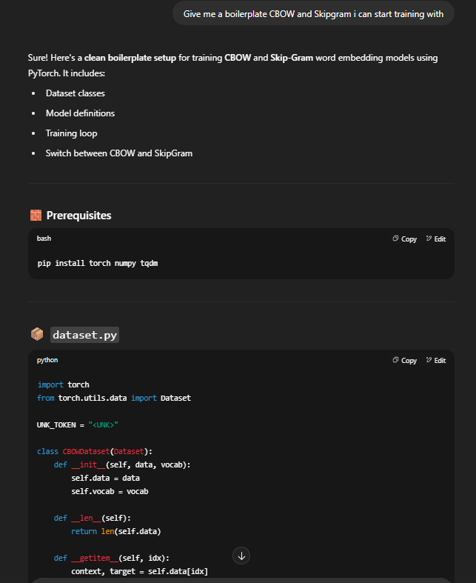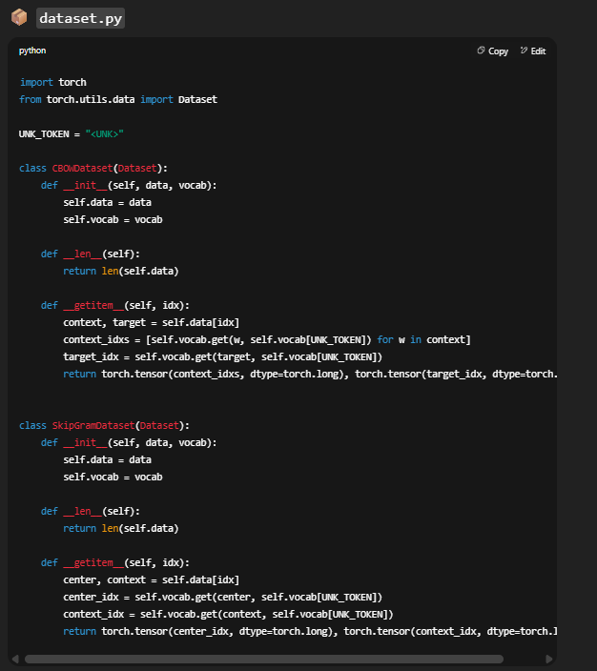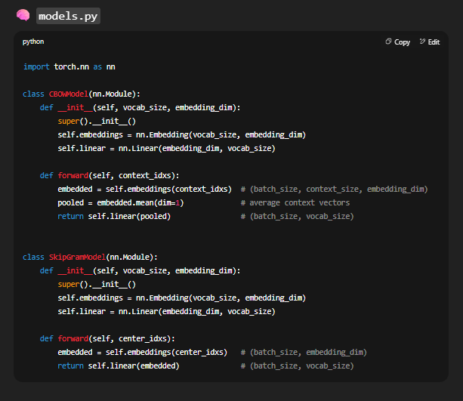

ChatGPT helped during error debugging, pointing out that the Colab training in the evaluation script needed to be loaded correctly.

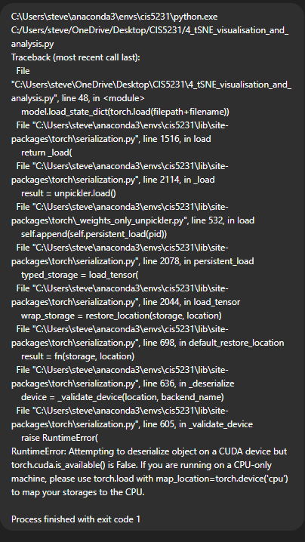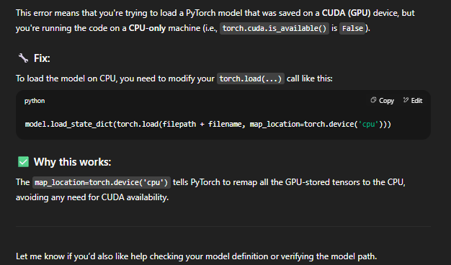

Code-wise, ChatGPT helped as well in the design choices: 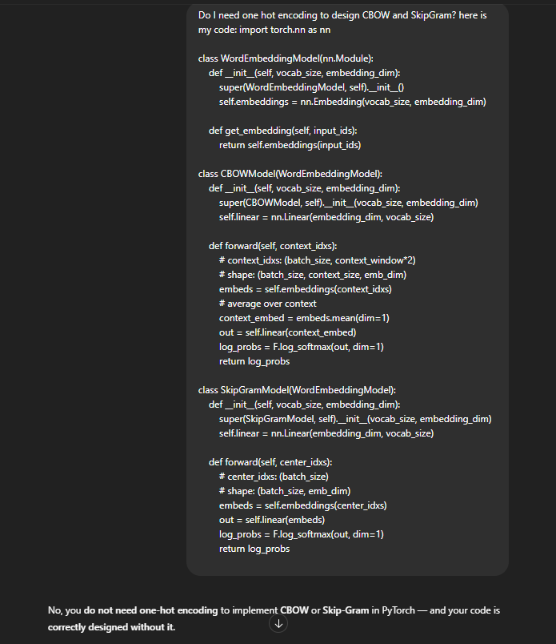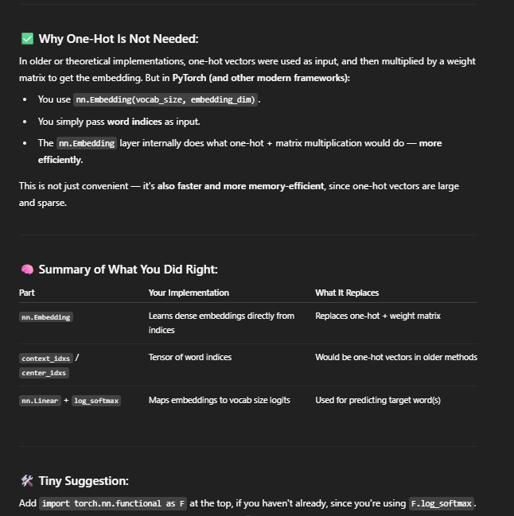

ChatGPT also helped to provide Pytorch lines of code that help with acceleration: 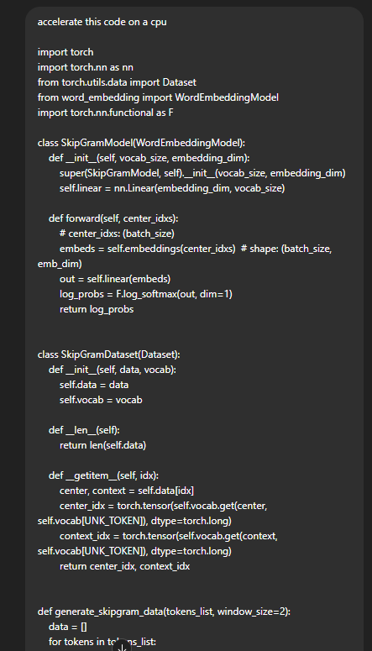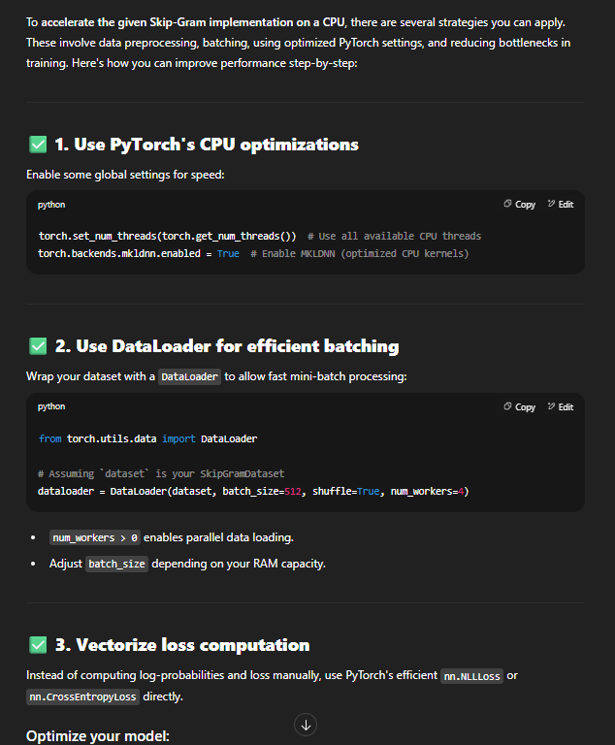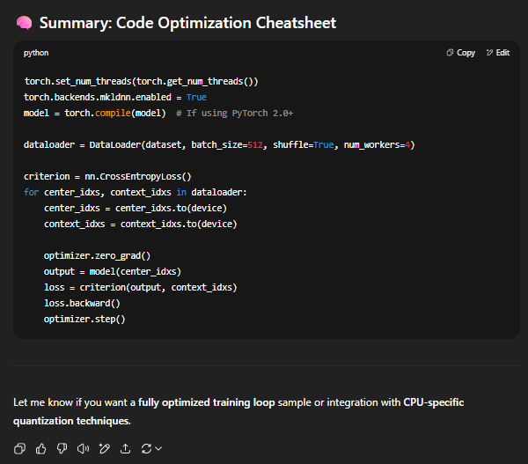

Ideas were provided for future enhancements:

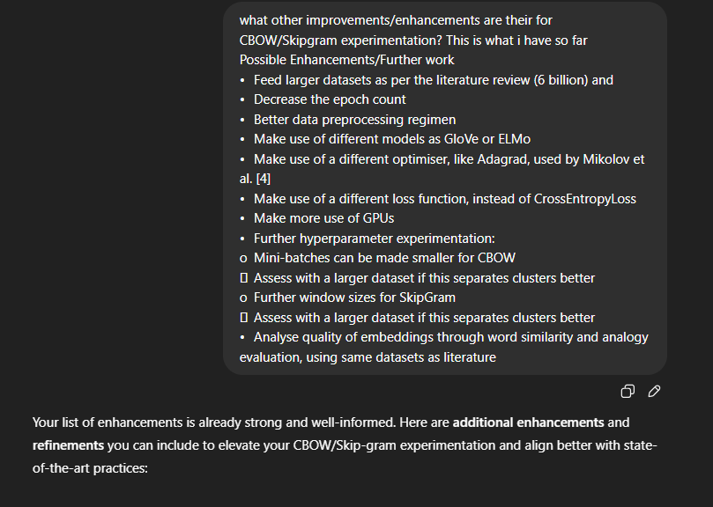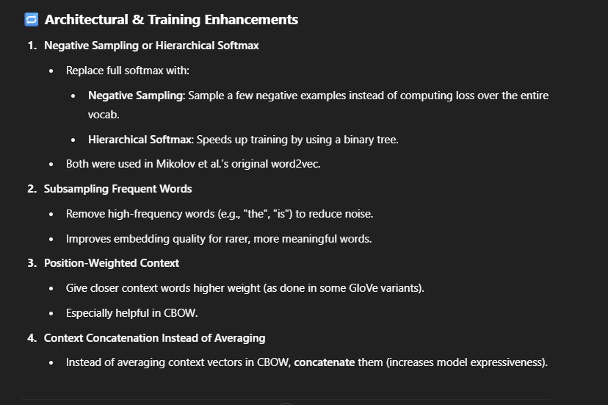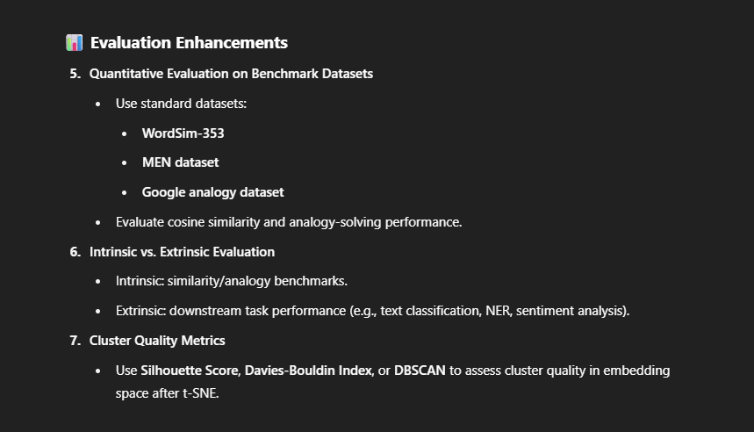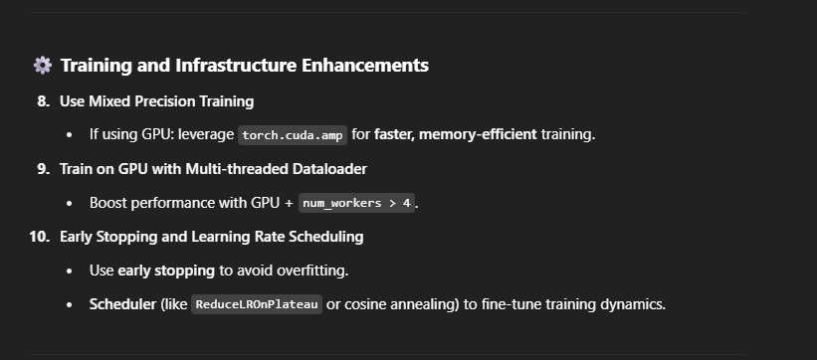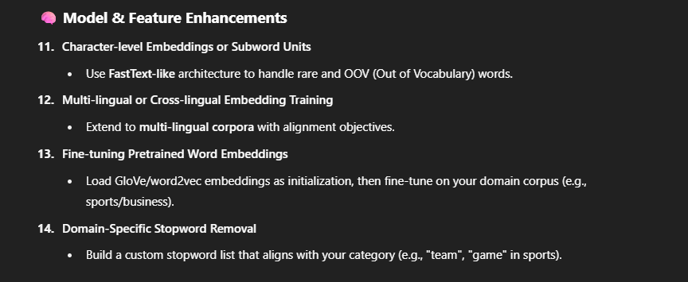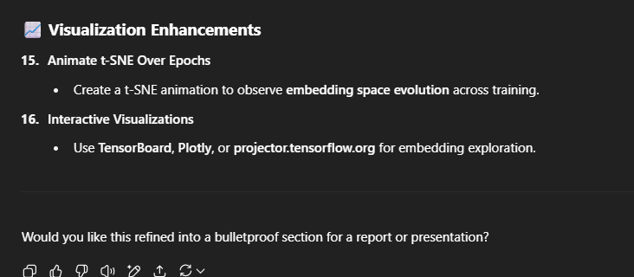  
  
English check: 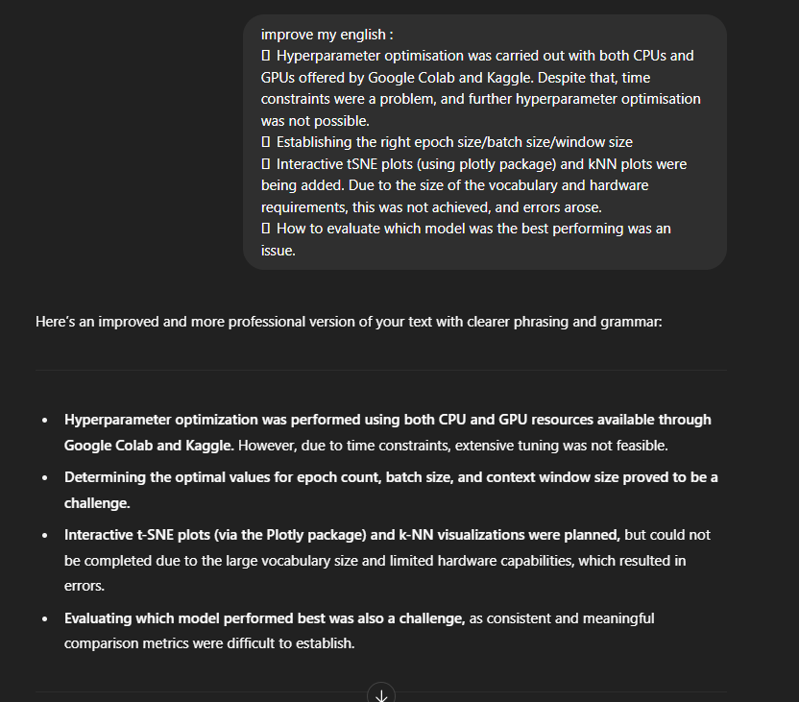

1. https://www.kaggle.com/datasets/asad1m9a9h6mood/news-articles